**Summer Math Work**

**for students**

**Entering 2nd Grade**



**WCS - FH 2025**

**Name:**

**Dear Families,**

As we wrap up a wonderful year of math learning, we’re sending home a packet of activities designed to help your child **keep their skills strong over the summer**. These sheets include work that was part of this year’s curriculum—so your child will recognize the content and be able to build on what they’ve already learned.

We know summer is a time for rest and play, but just a little bit of math practice each week can make a big difference. **Research shows that students often lose 2–3 months of math learning over the summer—more than they tend to lose in reading.** That’s because math skills, especially number sense and fluency, aren’t as naturally reinforced through everyday activities the way reading often is. That’s why we’re encouraging families to keep math fresh through short practice sessions or by finding ways to embed math into daily life—whether it’s splitting a pizza, measuring for a recipe, or playing a card or dice game.

**💡 What to Do If Your Child Gets Stuck:**

* **Remind them it’s okay not to know right away.** A little struggle is part of learning.
* **Help them start with what they *do* know.** Reading directions aloud or talking it through often helps.
* **Keep sessions short and positive.** 10–15 minutes at a time is perfect.
* **Use real-life moments to explore math**—from cooking to counting to sharing fairly.
* **Check out free online supports** like Khan Academy, YouTube, or Math Playground if you want a refresher or example.
* **Celebrate effort over perfection.** Every bit of practice helps!

Thank you for being our partners in learning this year. We hope this packet helps keep your child’s math brain active, without taking away from the joy of summer. Have fun with it—and don’t hesitate to reach out to Noelle, the Fernhill Math Specialist, [[n.campgana@wissahickoncharter.org](mailto:n.campgana@wissahickoncharter.org)] if you have questions.

**Happy Summer!**



**Directions**

1. Read the student and family page each week.
2. Try the activity of the week.
3. Complete the math pages.

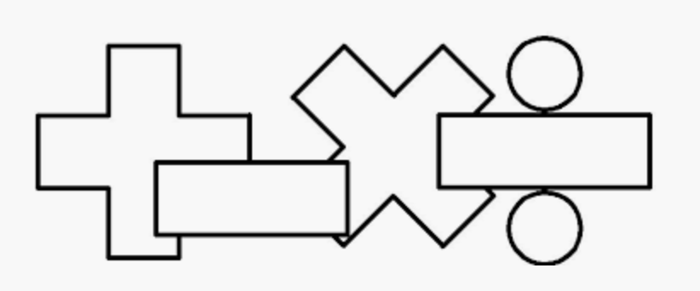

| **New 2nd graders should..** | **Families should...** |
| --- | --- |
| * Talk to your family about completing the activity of the week. Write or draw about what you did. * Do your math pages each week. Make sure you show your work! | * Talk to your child about the math they are doing. There are questions you can ask on the family instruction page and activities to do together as a family. * Reach out to Mr. Jack with any questions! |

**Week 1**

**I can…** add numbers to 20.



___________________________________________________

**For Families**

| **Understanding the Math:** In first grade, students spent a lot of time learning different strategies to add and used many different tools. You may be thinking, why not just memorize the facts? The different strategies help students develop fluency with their math facts. They also teach number sense, which will help greatly when students continue into more challenging math. Using tools helps your child see the math in their mind's eye which also helps develop fluency. Both of these things help your child become a flexible and accurate problem solver! | |
| --- | --- |
| **Resources:**  -Your child practiced adding using a number rack. Here is a digital one: <https://apps.mathlearningcenter.org/number-rack/> Have your child use it to build any of the problems you are working on by sliding the amount over from left to right.  -Some strategies students learned this year: doubles facts (5+5, 8+8), doubles plus or minus 1 (6+5, 7+8), make ten facts (7+4 = 7+3+1), count on facts (7+2), and add ten facts (4+10). | **Questions to Ask Your Child :**  -How did you solve that problem?  -Can you build ____ on the number rack?  -Can you use what you know about double’s facts to help you?  -How could you use a make ten fact to help you solve this problem? |

Activity of the Week

Write your own addition problem! Make up a story problem uses addition. Write it down (or have a family member help you!) and draw a picture of your problem. Don’t forget to find the total!

|  |
| --- |

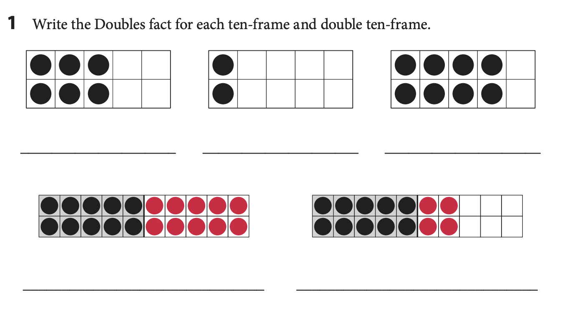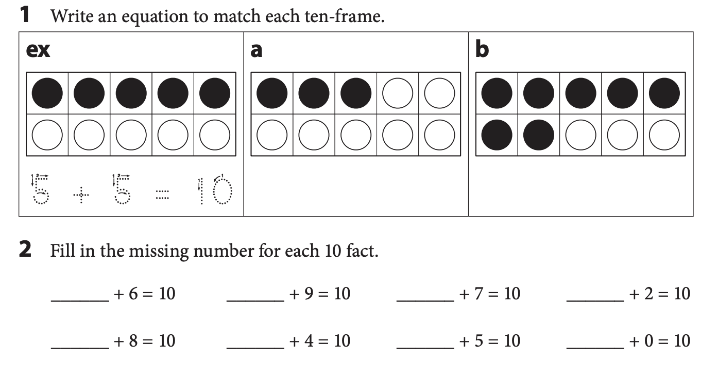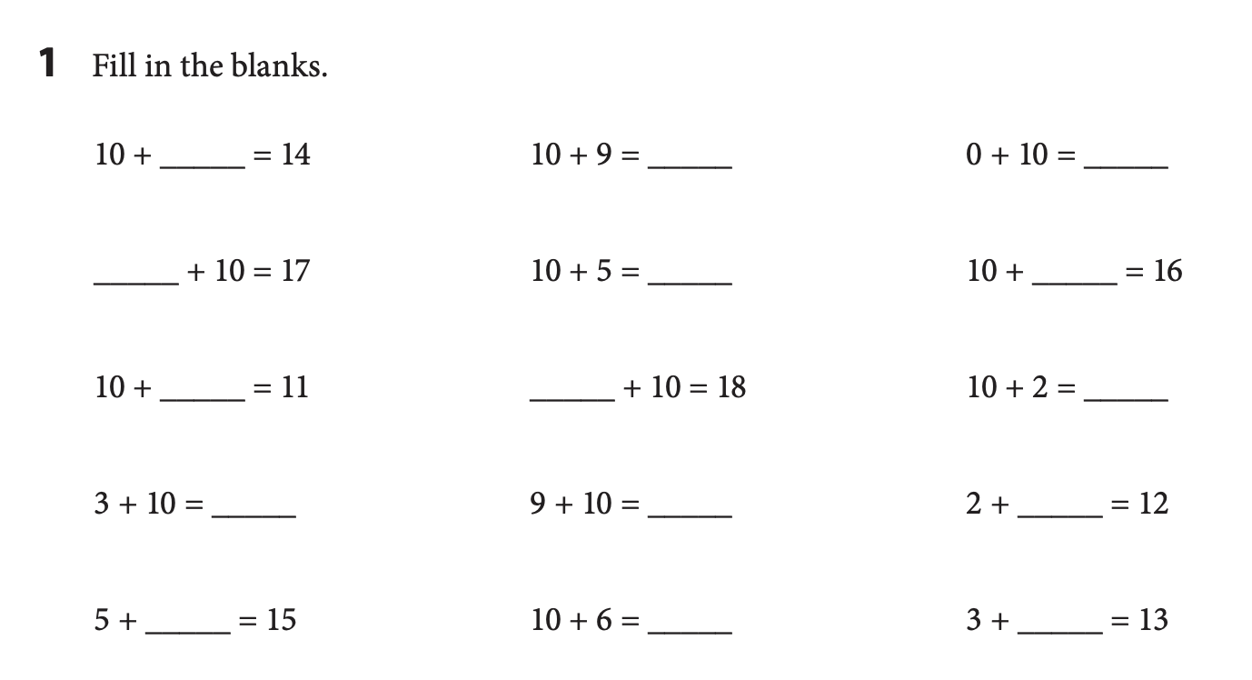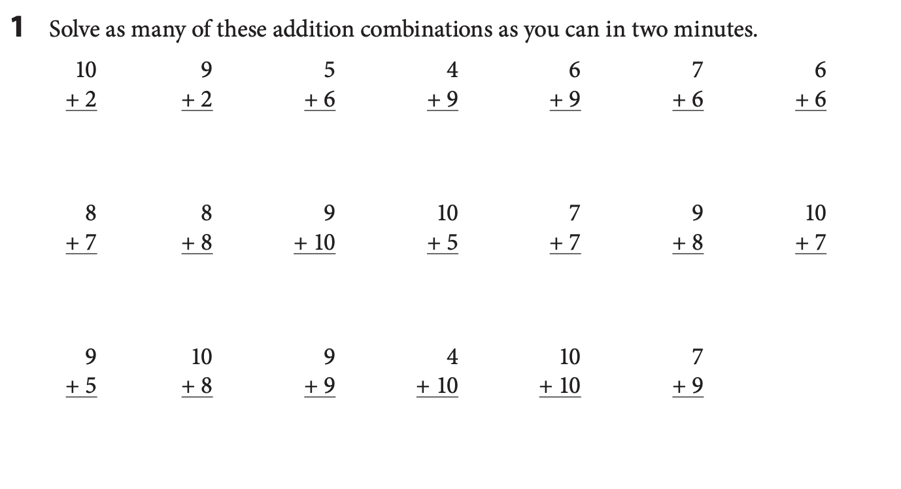

**Week 2**

**I can…** subtract numbers within 20.

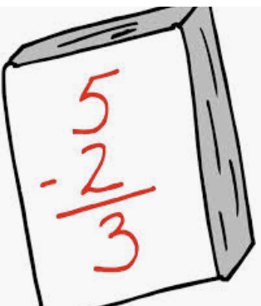

___________________________________________________

**For Families**

| **Understanding the math:** Your child learned a lot of strategies for subtraction this year! They may still be counting on their fingers too, though. Don’t be alarmed by this. Fingers are actually a great visual tool. They help us see relationships between numbers. When shown on your fingers, you can easily see that 7 is made up of 5 and 2 which can help you remember that math fact. Children will eventually no longer need their fingers to help them add and subtract, but for now, it's okay if they are still using them! | |
| --- | --- |
| **Resources:**  -Your child practiced subtracting this year using a number rack. Here is a digital one: <https://apps.mathlearningcenter.org/number-rack/> Have your child build the first number in the subtraction problem by sliding beads to the right. Then they can slide beads to the right to subtract. Try to encourage them to slide bigger groups than just one at a time. | **Questions to Ask Your Child :**   * How did you know ____? * What strategy did you use to find ______? * Can you build this problem on a number rack? * Can you draw a picture of this problem? |

Activity of the Week

Write your own subtraction problem! Make up a story problem that has subtraction. Write it down and draw a picture of your problem. Don’t forget to find the difference!

|  |
| --- |

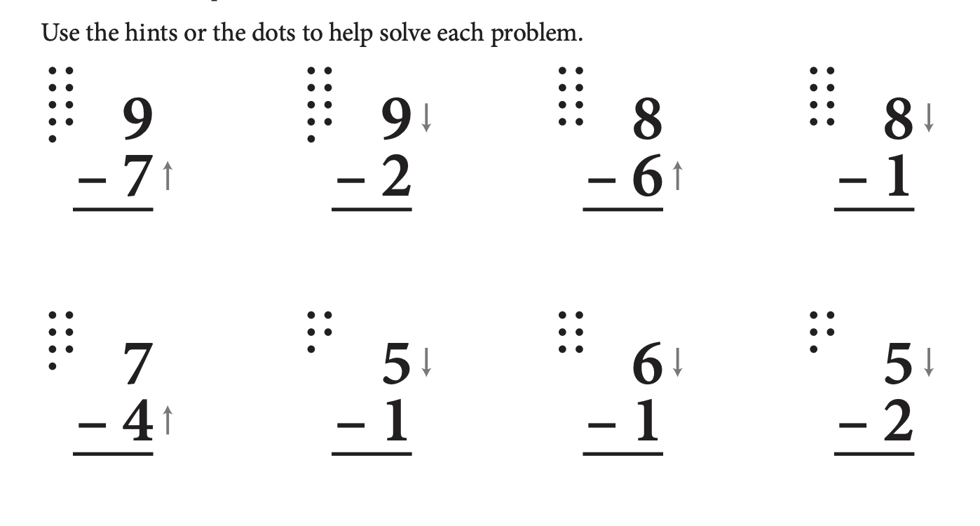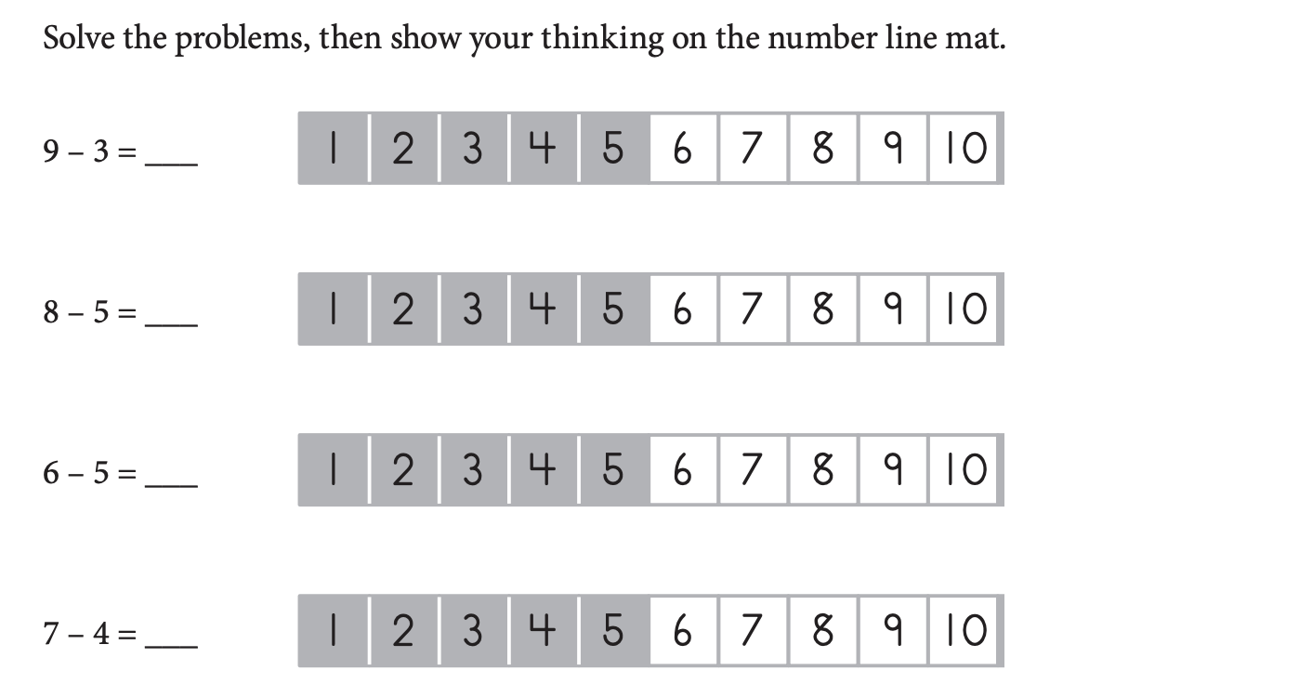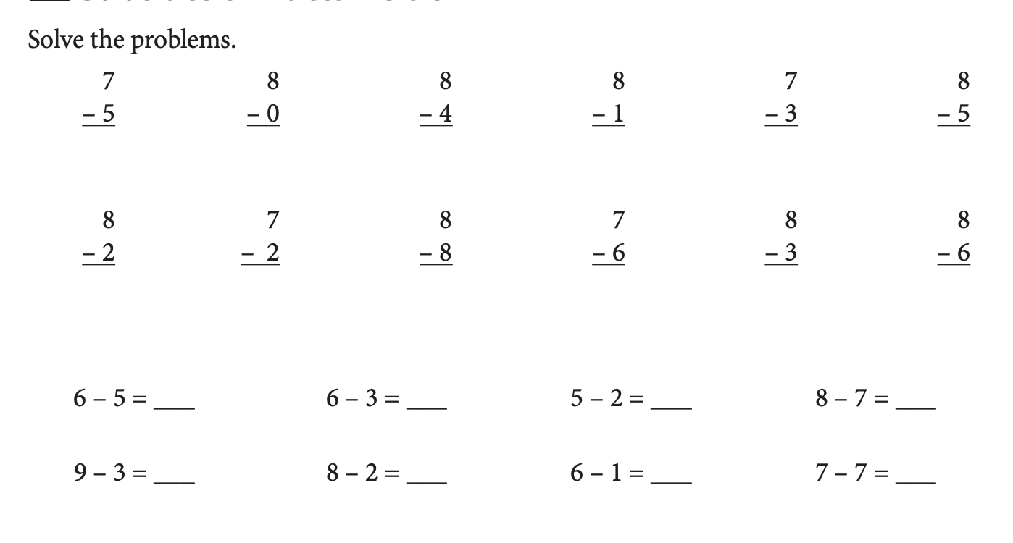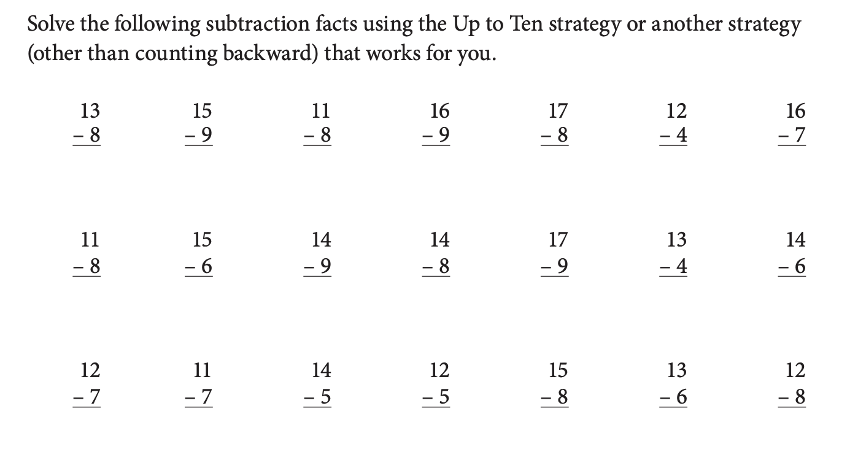

**Week 3**

**I can…** create addition and subtraction fact families.

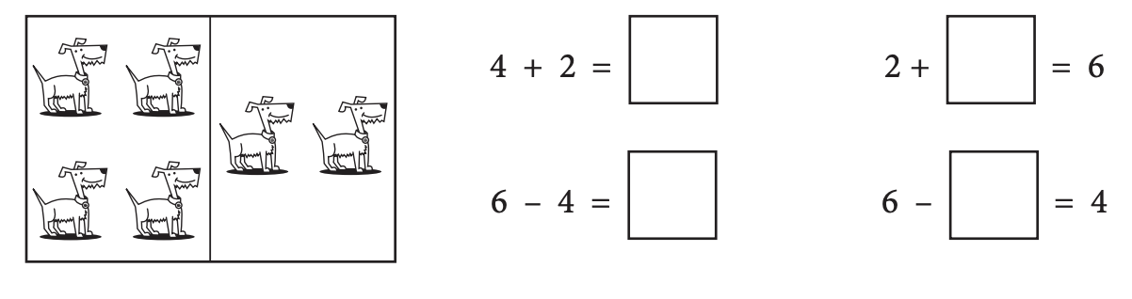

______________________________________________________________________

**For Families**

| **Understanding the math:** Fact families are a set of related addition and subtraction problems (see above). You might be asking, why bother teaching fact families- my child should just memorize their addition and subtraction facts. Understanding fact families actually helps students with memorizing their addition and subtraction facts. If your child has memorized one fact in the fact family- maybe 4+2=6 and if they understand fact families, they now will quickly be able to memorize the other three related facts! | |
| --- | --- |
| **Resources:**  -In first grade your child made flap cards (like the one with the dogs above). There are two sections, for two of the numbers in the fact family on one flap and the other flap has the other number in the fact family. Moving these flaps around, they were able to visually see fact families.  -Playing with dominos is a great way to practice fact families! Your child can see the dots on each side and find the total. | **Questions to Ask Your Child :**  -Is there a fact you know that can help you with this problem?  -What are the three numbers in the fact family? Which number is the total?  -Can you write the four facts in this fact family? |

Activity of the Week

Grab 10 of your favorite toys or snacks. Act out two story problems with them. One should show 4+6 and another should show 10-3. Draw a picture of what you used and write your solution below.

|  |
| --- |

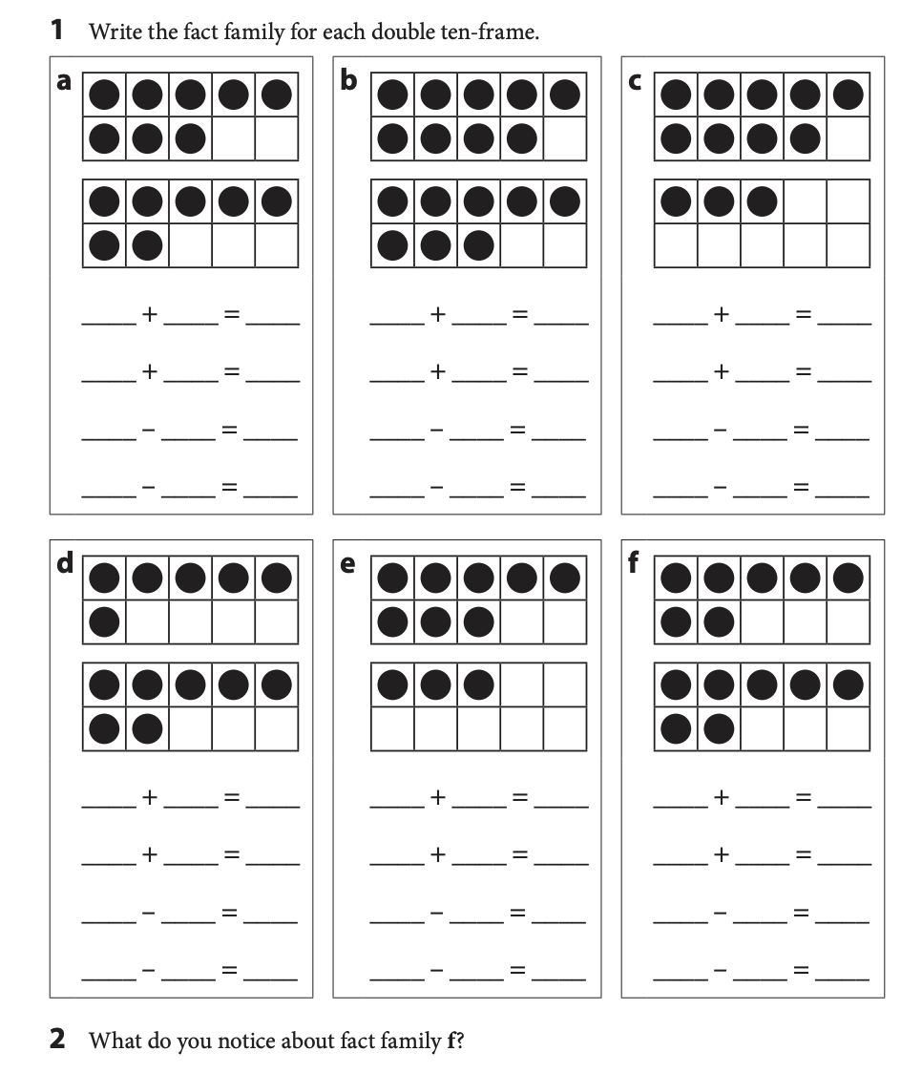

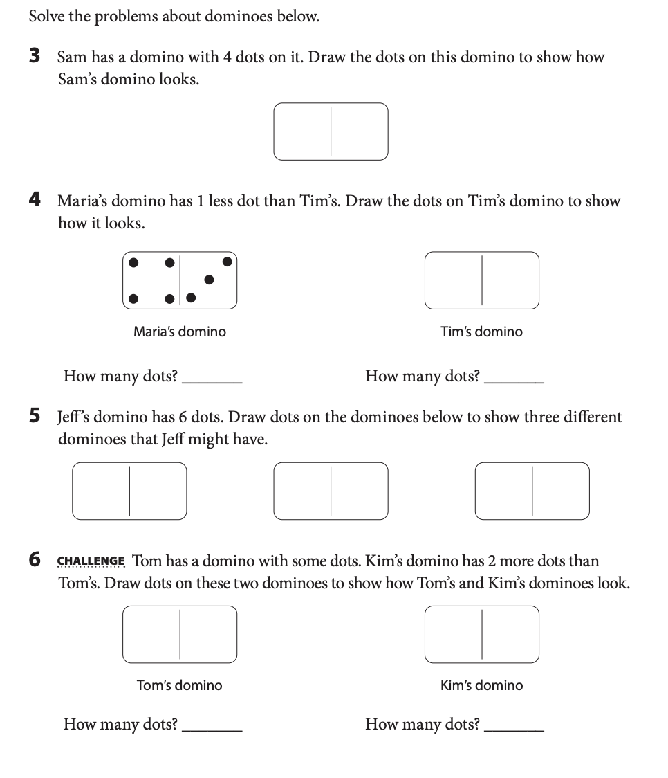

**Week 4**

**I can…** solve word problems using addition and subtraction.

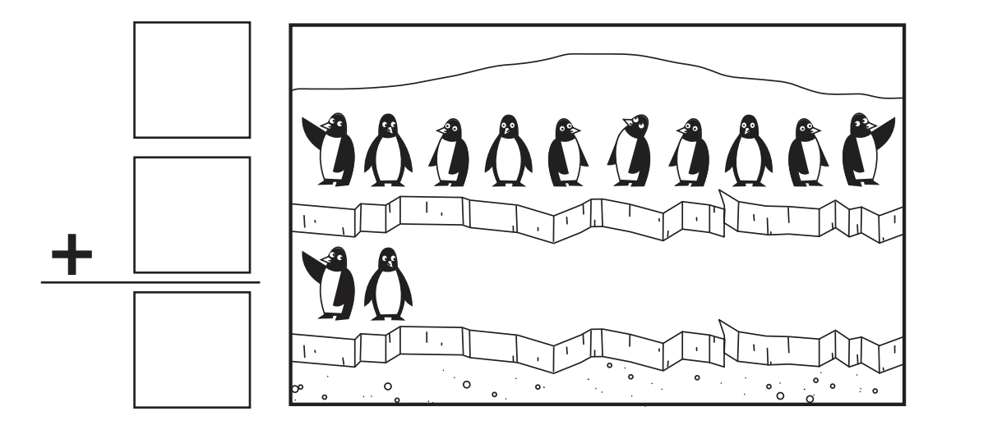

___________________________________________________

**For Families**

| **Understanding the math:** Word problems can be particularly challenging for any age student! One of the best ways you can help your child with word problems is by helping them visualize the problem. There are lots of ways to do this. You can physically act out the problem together. You can use a tool like a number rack or counters. You can also have them draw a picture of what is happening. Once they can clearly visualize the problem, they can then focus on the math to solve it! | |
| --- | --- |
| **Resources:**  -Using the number rack will again be very helpful with word problems. Students can build what is happening using the number rack. Here is the digital one: <https://apps.mathlearningcenter.org/number-rack/> | **Questions to Ask Your Child :**   * What do you know in this problem? What don’t you know? * Can you act out what is happening? Can you draw it? * Can you write a number sentence to match this problem? * What operation do you need to do to solve this problem? |

Activity of the Week

Write or draw a picture of a time you used math in real life.

|  |
| --- |

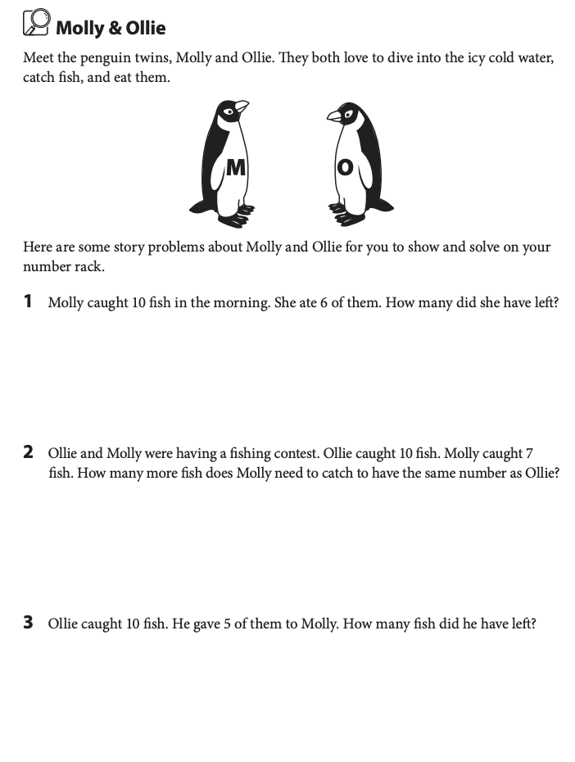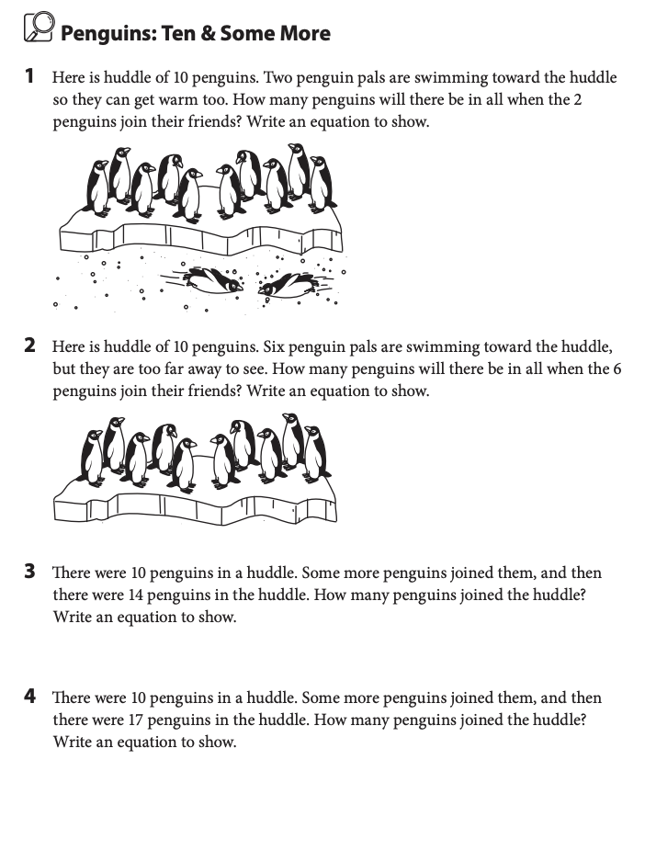

**Week 5**

**I can…** count by 10s, 5s and 2s.

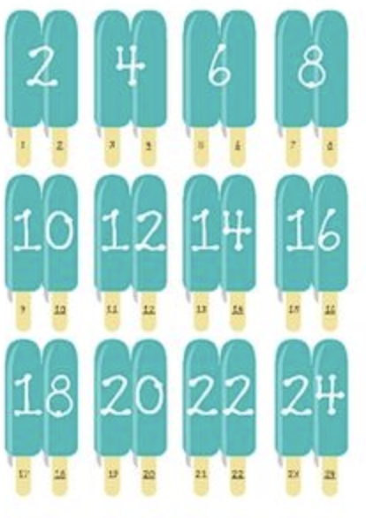

___________________________________________________

**For Families**

| **Understanding the math:** Your child probably can count by 10s and maybe 5s and 2s. It is important that they learn not just to memorize the pattern of numbers though but actually understand the pattern. That is why you will see that often we ask students to count by numbers “off decade”. This means counting by a number but starting at something other than 0. So if we counted by tens starting at 4, it would be “4, 14, 24, 34…” This skill, especially with 10s, is incredibly helpful when adding and subtracting in older grades. Practicing this will also help your child develop a deep understanding of our number system! | |
| --- | --- |
| **Resources:**  -Using a 100s chart can be very  helpful for counting, here is a digital  one: <https://toytheater.com/120-chart/> | **Questions to Ask Your Child :**  -Can you count by ___ starting at ___?  -Can you count backwards by ____? |

Activity of the Week

Create a collection! This could be seashells you find at the beach, cool leaves from the park, your toy cars, or rocks-- anything you can think of! Draw a picture of what you collected. Count how many you found by 10s, 5s, and 2s.

|  |
| --- |

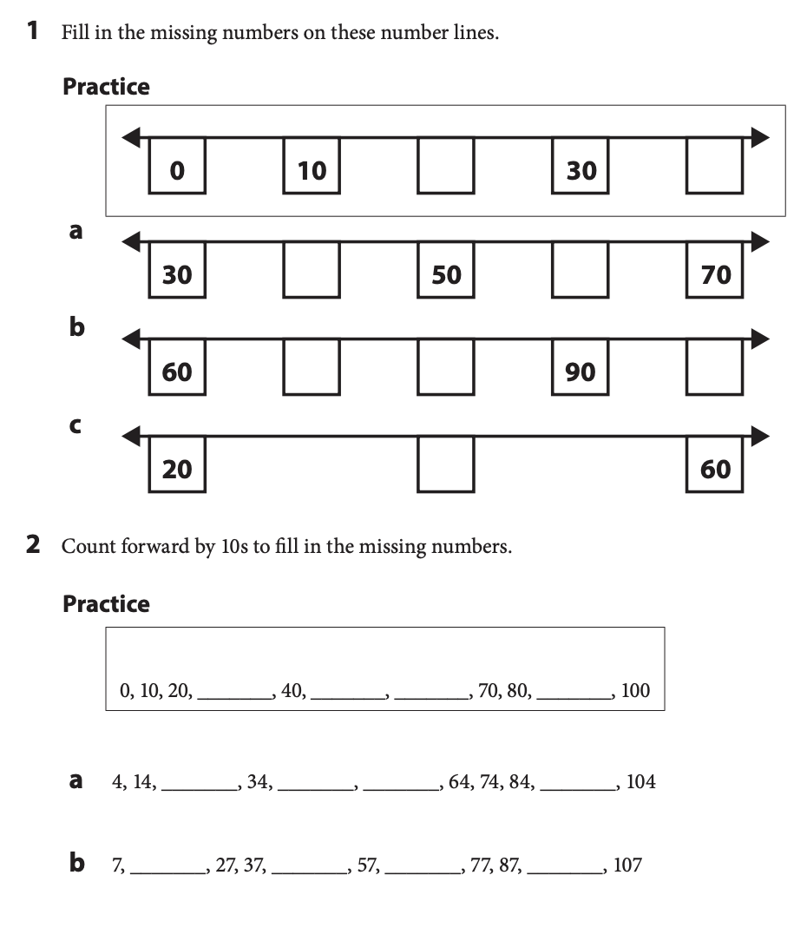

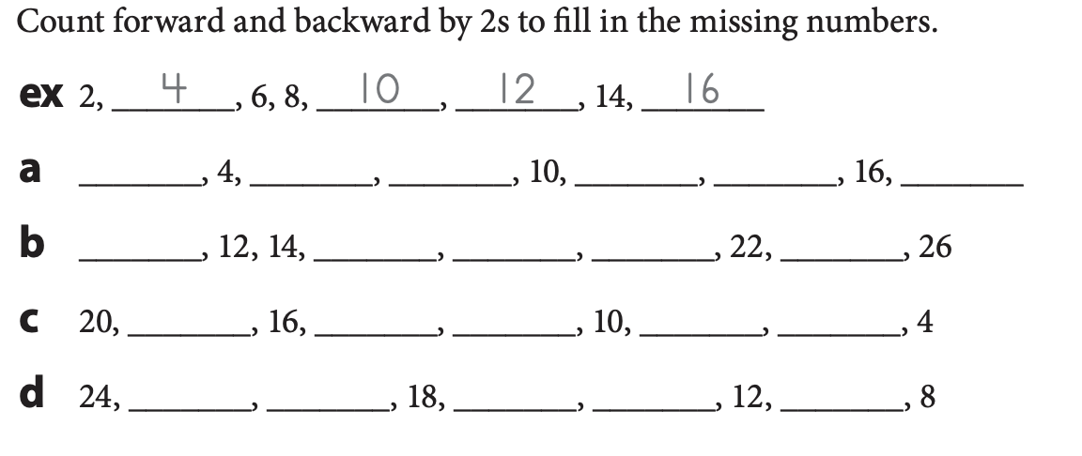



**Week 6**

**I can…** tell how many tens and how many ones make a number.

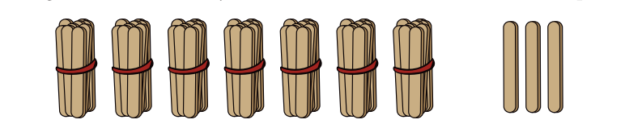

___________________________________________________

**For Families**

| **Understanding the math:** Place value means understanding numbers in our “base ten” system which means numbers are made up of groups of 10s. 7 tens is 70, 10 hundreds is 1,000, 10 hundred-thousands is a million! When students practice building bundles of 10s like the sticks you see above, they develop a deeper understanding of our number system and faster ways to count. Understanding place value helps students understand decimals, multiplication, addition, and exponents, just to name a few things! | |
| --- | --- |
| **Resources:**  **-**In second grade, students will begin to work with place value blocks (premade objects that show groups of 1s, 10s, and 100s.) You can introduce your child to these this summer at: <https://apps.mathlearningcenter.org/number-pieces/>Try clicking the red, yellow, and green squares at the bottom left and then have your child build different numbers! | **Questions to Ask Your Child :**  -How many bundles of 10 are in 64? What if I added another bundle of ten? What if I took 2 bundles away?  -How many loose sticks would you have left over if you built the number 35? (5)  -Can you write a number sentence to show 73? (70+3) |

Activity of the Week

Go on a big number hunt! Find two big numbers in your house or your neighborhood. Try to figure out how many 10s, and 1s are in that number. Draw or write what you found and how many 10s and 1s.

| EX: I found a puzzle that had 52 pieces. There are 5 tens, and 2 ones in in 52. |
| --- |

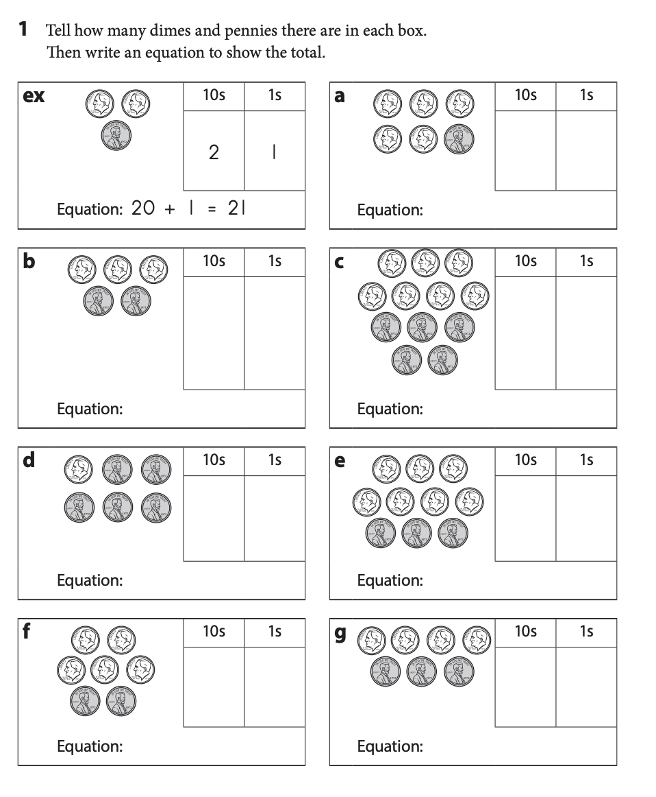

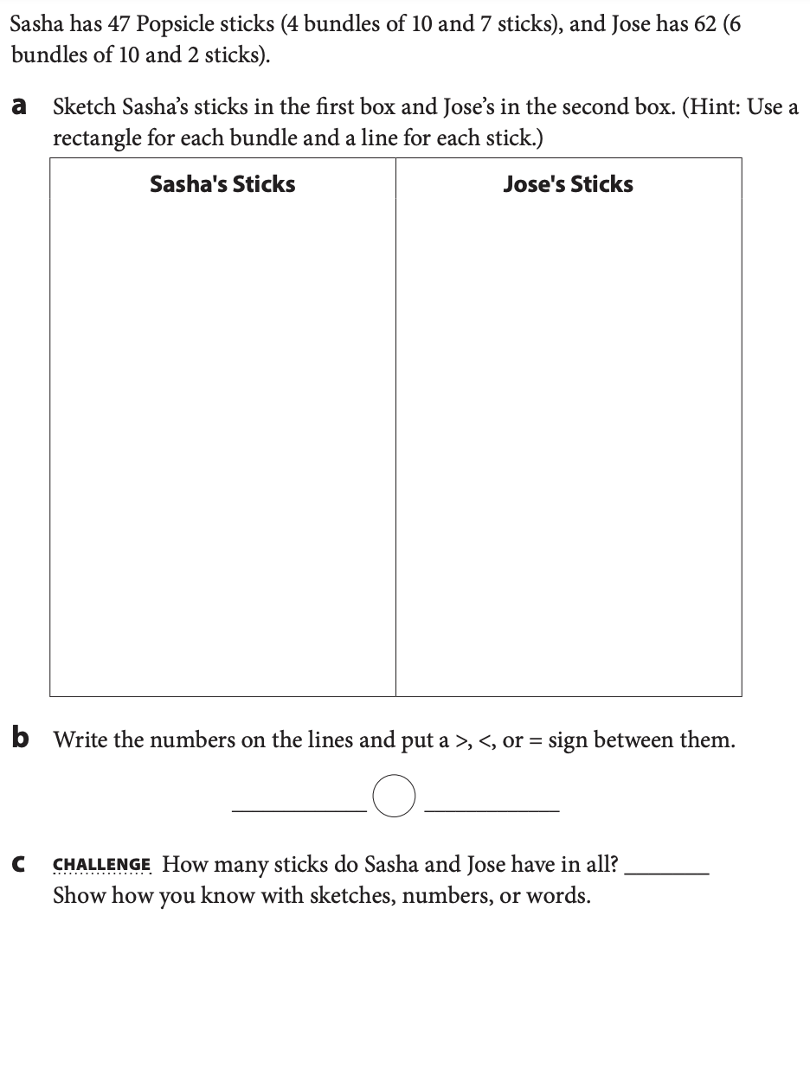

**Week 7**

**I can…** use what I know about 10s and 1s to add and subtract.

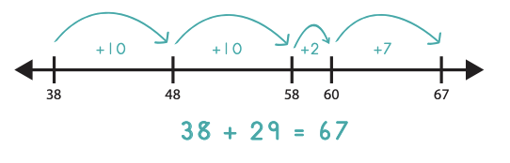

___________________________________________________

**For Families**

| **Understanding the math:** Using a number line to add and subtract is something we emphasize heavily in 1st and 2nd grade. You may be thinking, why not just teach them the way I learned? Often when we just teach the standard addition and subtraction methods, students don’t actually understand what they are doing. They may know they need to “borrow” but don’t know what this means. Just teaching the standard way often leads to mistakes and frustration and does not teach students number sense. Using a number line helps students visualize numbers and their relationships. It also helps them learn mental math strategies. Once they are very comfortable with the number line, we will teach them the standard methods! | |
| --- | --- |
| **Tips:**  -Here is a digital number line: <https://apps.mathlearningcenter.org/number-line/>  -Try adding numbers yourself on the number line! You may find that you actually mentally often use strategies you would use if drawing jumps on a number line. | **Questions to Ask Your Child :**  **-**What will you jump first? Why?  -Can you take bigger jumps than just 1?  -Is there another way you could jump on the number line?  -Where would you land if you added ten? |

Activity of the Week

Create a giant number line on the ground! You can use sidewalk chalk, a string, or just a straight line. Use big jumps to represent hops of 10 and small steps to represent hops of one. Solve 22+14 on your giant number line. Write what you did. Then try to have your family tell you other problems to solve!

| EX: If I solve 16+11, I would pretend that the beginning of my number line was 16. To first add 10 to 16, I would take one big jump and land on 26. Then, I would take one small step to represent adding 1. I landed at 27. |
| --- |

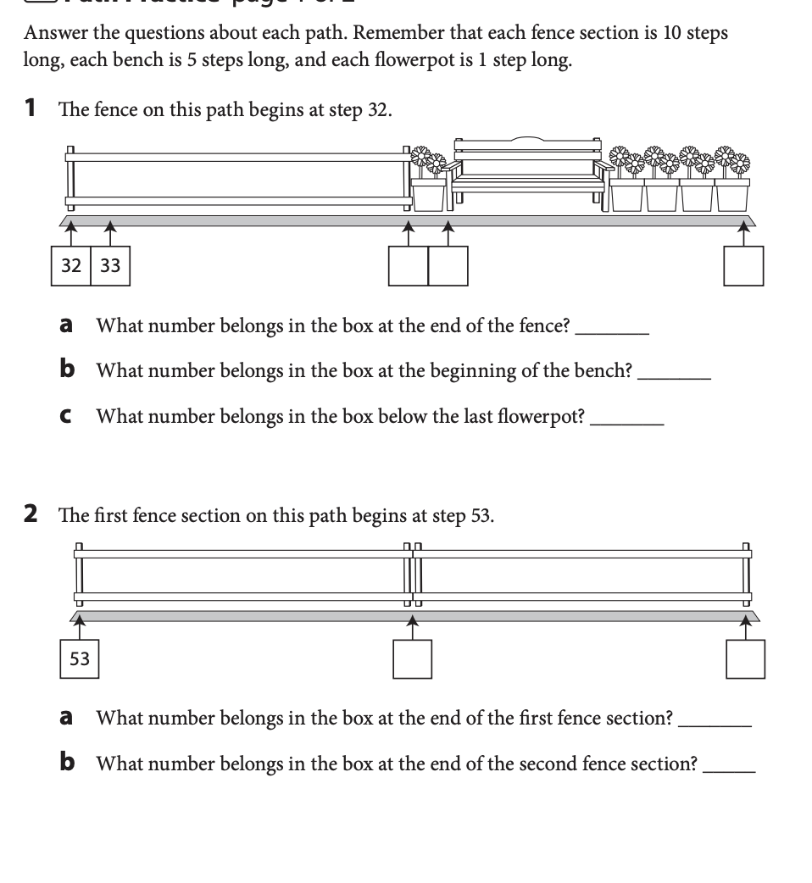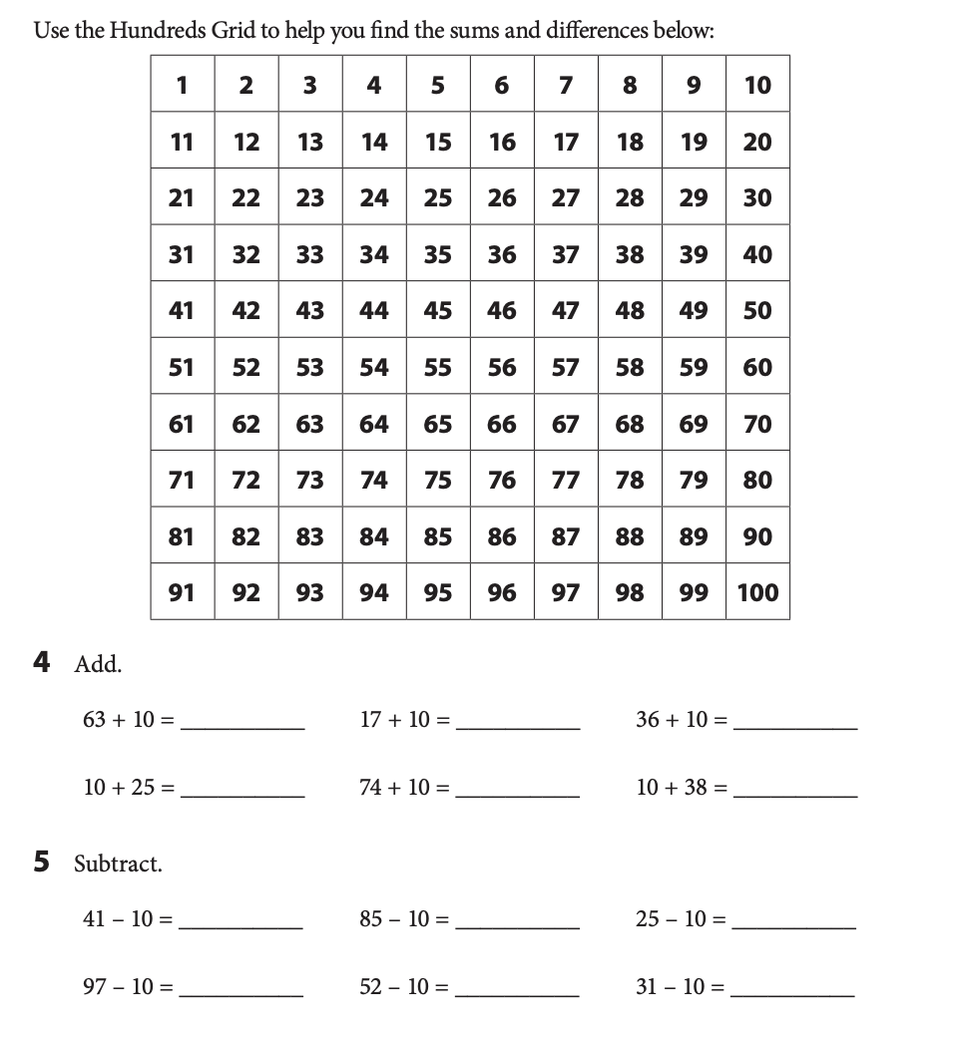

**Week 8**

**I can…** split shapes into halves and fourths and name the parts.

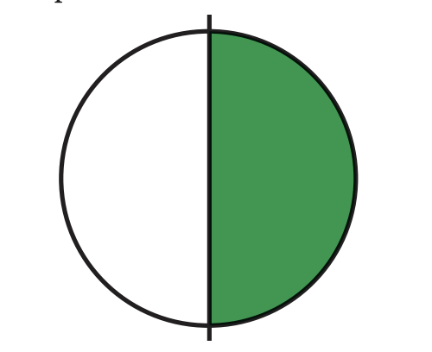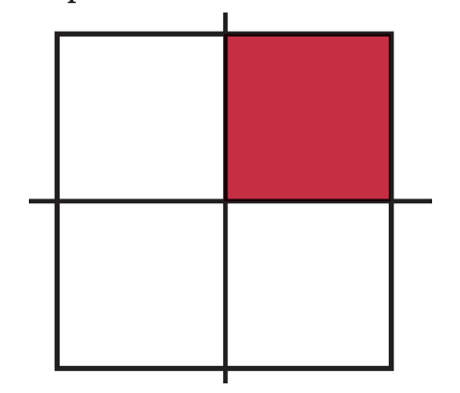

______________________________________________________

**For Families**

| **Understanding the math:** When you ask adults about their experience with fractions, many do not remember them fondly! This is often because they didn't have a deep understanding of fractions before they tried to add, subtract, multiply, and divide them! Your child learned very basic fraction skills in 1st grade. This early introduction will help ensure that they are not afraid of fractions when they are older! Note that first graders mainly focused on halves and fourths. | |
| --- | --- |
| **Resources:**  -You child knew about fractions before they even entered school. You probably taught your child about them! (*You can have half of this candy, split it in half to share!*) We naturally talk about sharing things often. Try to include your child even more in these conversations. Split your cookie in fourths, give your child one, ask how much of the cookie they got. Opportunities to talk about fractions are endless! | **Questions to Ask Your Child :**  -How many fourths make a whole?  -How much of this candy bar do I have?  -Can you split my sandwich into fourths? What is each part of my sandwich called?  -Would you rather have ½ of a chocolate cake or ¼? |

Activity of the Week

Build shapes out of play doh, clay, sand or mud OR paint or draw some shapes. Divide the shapes into halves and fourths. Draw or write about what you did.

|  |
| --- |

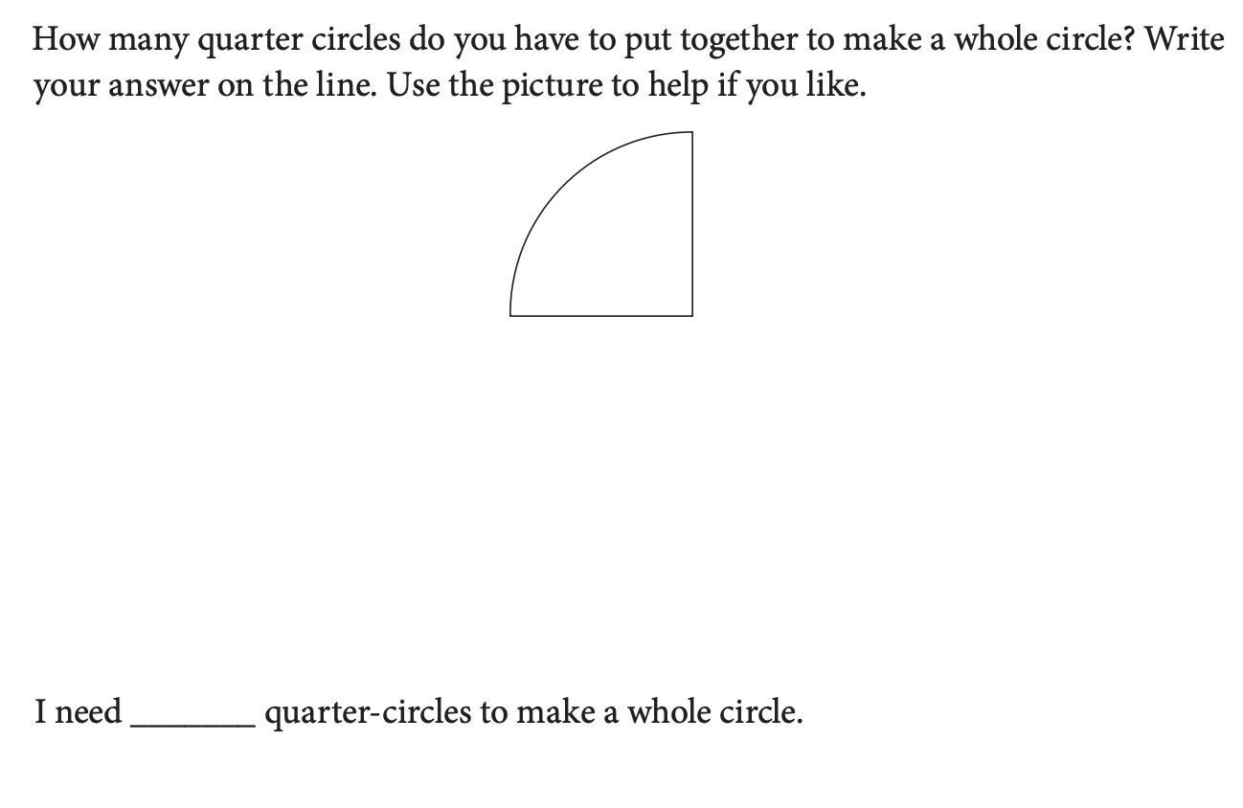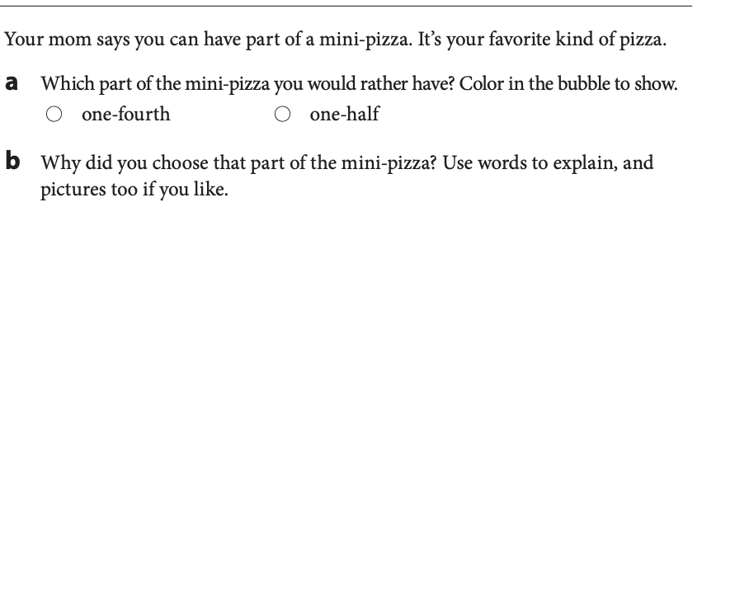

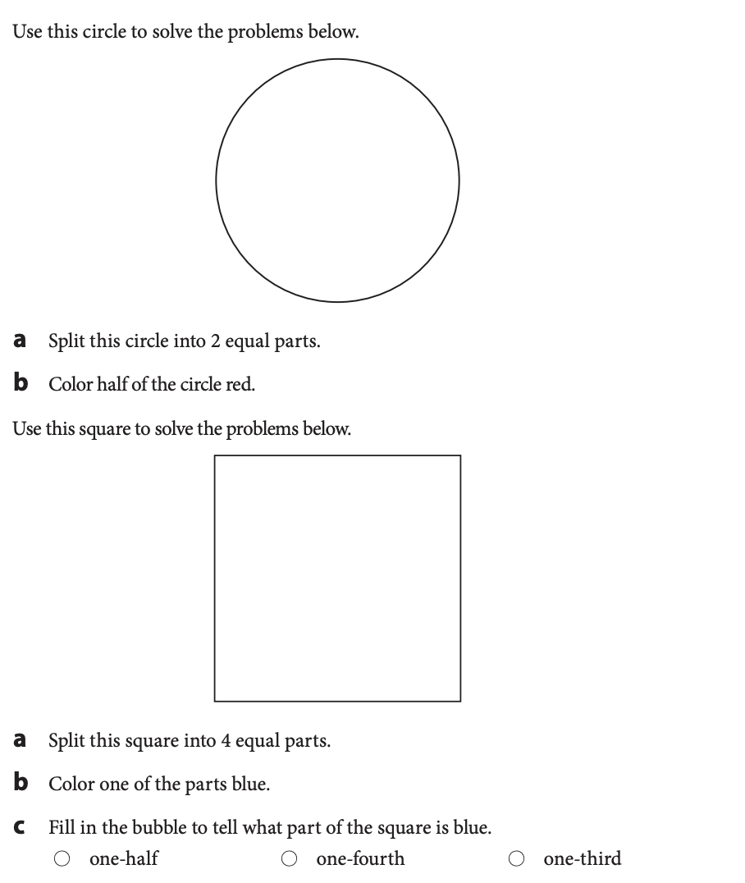

**Week 9**

**I can…** I can tell time to the nearest half hour.

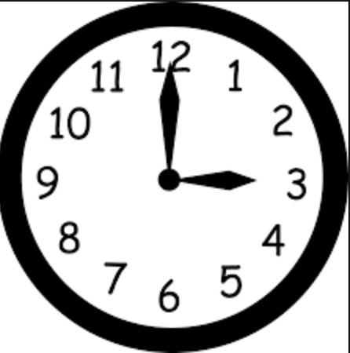

___________________________________________________

**For Families**

| **Understanding the math:** In first grade, your child learned how to tell time to the hour and half hour (not yet to the minute). Telling time is another great math skill to just talk with your child about. Tell them the time things are happening and ask them what time it is Even though most of us don’t have analog clocks, it’s still a valuable skill to be able to read one. Telling time on an analogue clock also helps children count by fives and understand fractions (for example-half an hour). | |
| --- | --- |
| **Resources:**  -Here is a virtual analogue clock to use with your child. <https://toytheater.com/clock/> | **Questions to Ask Your Child :**  -What time is it?  -How did you know it was ____?  -Where does the hour hand point when it's ___ o’clock?  -Where does the minute hand point when it’s 8:30?  -How many hours until ____? |

Activity of the Week

With the help of your family create a schedule for your day with the time and activity and write it below. Your schedule should have 5 things to do on it. Try to follow it! Check the clock frequently to see if you are on schedule!

|  |
| --- |

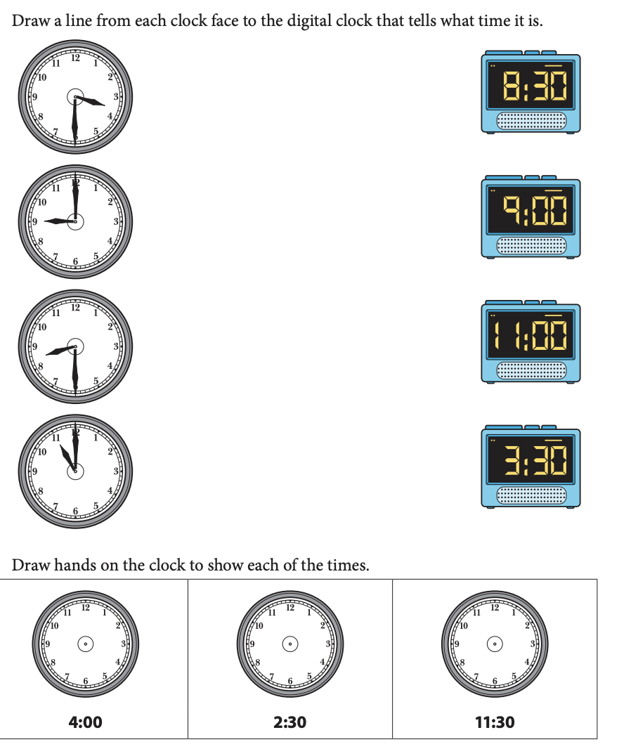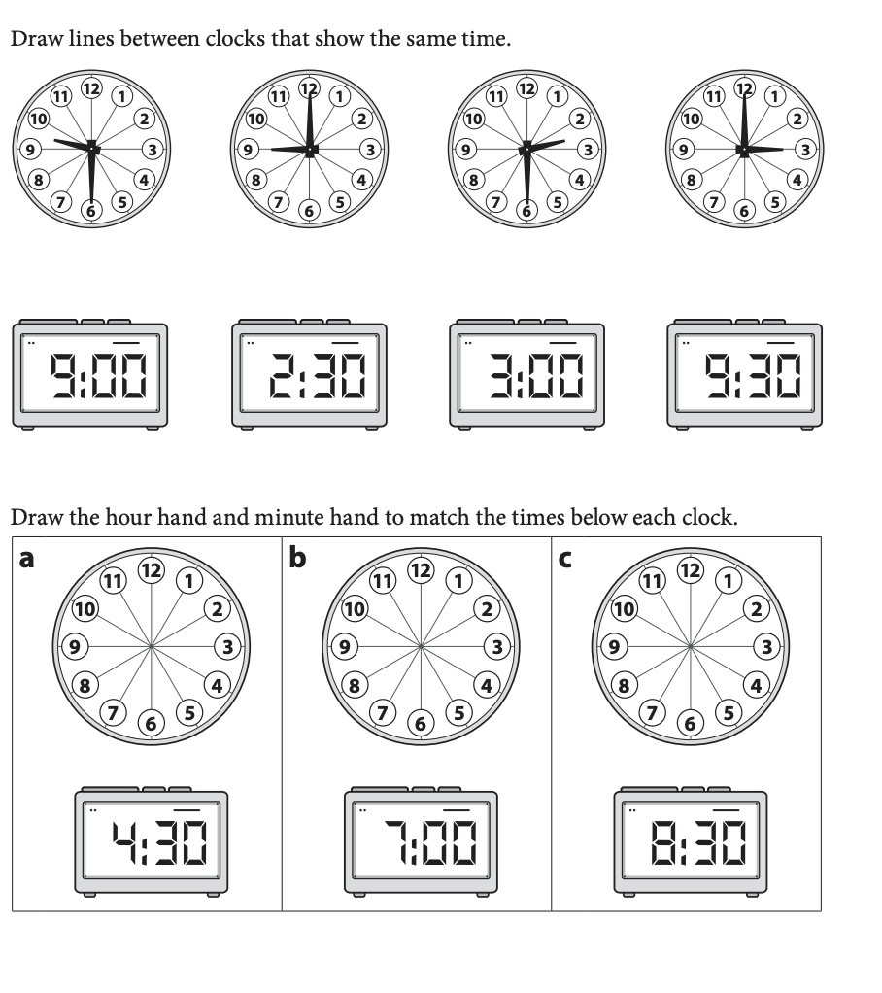

**Week 10**

**I can…** create and answer questions about graphs.

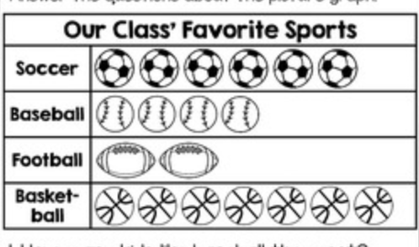

___________________________________________________

**For Families**

| **Understanding the math:** In first grade your child learned about a few types of graphs: Picture graphs, like the one above, tally charts (with tally marks), and bar graphs (graphs with bars above or to the side of each option). Graphs help us organize our thinking, make conclusions, and show information. It is important for your child to be able to create and interpret graphs not just for their future math learning, but also as a skill they will use throughout their life. They will use graphs in science class, they will see graphs in their history textbooks, and they will see graphs in news stories. Being able to understand graphs is a lifelong skill! | |
| --- | --- |
| **Resources:**  **-**Children love to ask questions and learn about their families. Help them to create graphs about what they learn. Here is a virtual graph making tool you can use: [https://toytheater.com/graph-color-bars](https://toytheater.com/graph-color-bars/)/ | **Questions to Ask Your Child :**  -Which has the most? How do you know?  -How many votes does ___ have?  -How many more ____ than ____ are there?  -What is the total number of votes? |

Activity of the Week

Create a yes or no question survey for your family (for example, do you like pizza?). Try to ask 10 people. It’s a great excuse to call family members! Make a graph of your survey below, coloring in the boxes for each answer. Then answer the questions.

| **Question: __________________________________________________________**  **___________________________________________________________________**   | Yes |  |  |  |  |  |  |  |  |  | | --- | --- | --- | --- | --- | --- | --- | --- | --- | --- | | No |  |  |  |  |  |  |  |  |  |   How many people voted yes? _____________  How many voted no? ______  Which answer got the most votes? _________ |
| --- | --- | --- | --- | --- | --- | --- | --- | --- | --- | --- | --- | --- | --- | --- | --- | --- | --- | --- | --- | --- |

