**Summer Math Work**

**for students**

**Entering 3rd Grade**

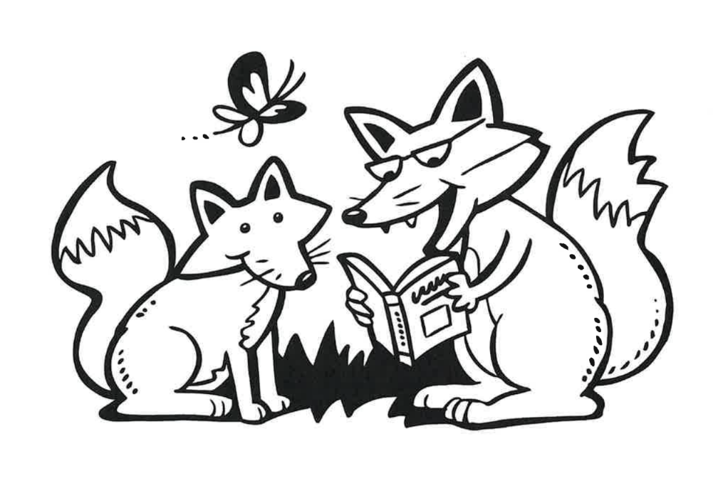

**WCS - FH 2025**

**Name:**

**Dear Families,**

As we wrap up a wonderful year of math learning, we’re sending home a packet of activities designed to help your child **keep their skills strong over the summer**. These sheets include work that was part of this year’s curriculum—so your child will recognize the content and be able to build on what they’ve already learned.

We know summer is a time for rest and play, but just a little bit of math practice each week can make a big difference. **Research shows that students often lose 2–3 months of math learning over the summer—more than they tend to lose in reading.** That’s because math skills, especially number sense and fluency, aren’t as naturally reinforced through everyday activities the way reading often is. That’s why we’re encouraging families to keep math fresh through short practice sessions or by finding ways to embed math into daily life—whether it’s splitting a pizza, measuring for a recipe, or playing a card or dice game.

**💡 What to Do If Your Child Gets Stuck:**

* **Remind them it’s okay not to know right away.** A little struggle is part of learning.
* **Help them start with what they *do* know.** Reading directions aloud or talking it through often helps.
* **Keep sessions short and positive.** 10–15 minutes at a time is perfect.
* **Use real-life moments to explore math**—from cooking to counting to sharing fairly.
* **Check out free online supports** like Khan Academy, YouTube, or Math Playground if you want a refresher or example.
* **Celebrate effort over perfection.** Every bit of practice helps!

Thank you for being our partners in learning this year. We hope this packet helps keep your child’s math brain active, without taking away from the joy of summer. Have fun with it—and don’t hesitate to reach out to Noelle, the Fernhill Math Specialist, [[n.campgana@wissahickoncharter.org](mailto:n.campgana@wissahickoncharter.org)] if you have questions.

**Happy Summer!**

**Directions**

1. Read the student and family page each week.
2. Try the activity of the week.
3. Complete the math pages.

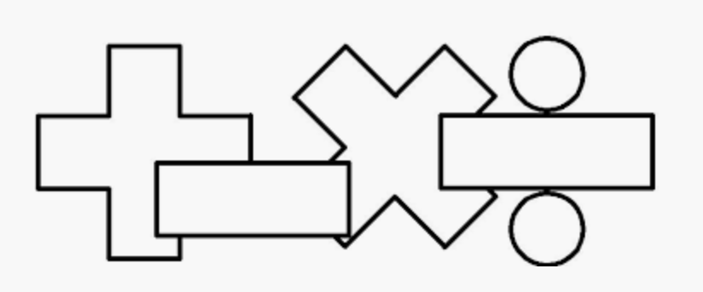

| **New 3rd graders should..** | **Families should...** |
| --- | --- |
| * Talk to your family about completing the activity of the week. Write or draw about what you did. * Do your math pages each week. Make sure you show your work! | * Talk to your child about the math they are doing. There are questions you can ask on the family instruction page and activities to do together as a family. * Reach out to Mr. Jack with any questions! |

**Week 1**

**I can…** add and subtract fluently within 20.

___________________________________________________

**For Families**

| **Understanding the math:** In first and second grade, students spent a lot of time learning different strategies to add and subtract. You may be thinking, why not just memorize the facts? The different strategies they learned actually help students develop fluency and memorize their math facts. They also teach number sense, which will help greatly when students continue to grow into more challenging math. As they enter 3rd grade though, they should begin to have many of their facts memorized. Work this summer on helping your child learn all their addition and subtraction facts! | |
| --- | --- |
| **Resources:**  -Your child practiced adding using a number rack. Here is a digital one: <https://apps.mathlearningcenter.org/number-rack/> Have your child use it to build any of the problems you are working on by sliding the amount over from left to right.  -You also can have your child memorize their facts using online flashcards: <https://toytheater.com/math-test/> Just select 1-19 and addition or subtraction. | **Questions to Ask Your Child :**  -How did you solve that problem?  -Can you build ____ on the number rack?  -Can you use a fact you already know to help you?  -How could you use an addition fact you know to help with this subtraction problem? |

Activity of the Week

Make your own flash cards! All you need is paper cut into rectangles. Write all the addition and subtraction facts you can with the solution on the back. Practice in the car, on the bus, when you're bored-- whenever! Try to add more facts once you learn all the ones you have. Write a list below of some of the facts you have memorized!

|  |
| --- |

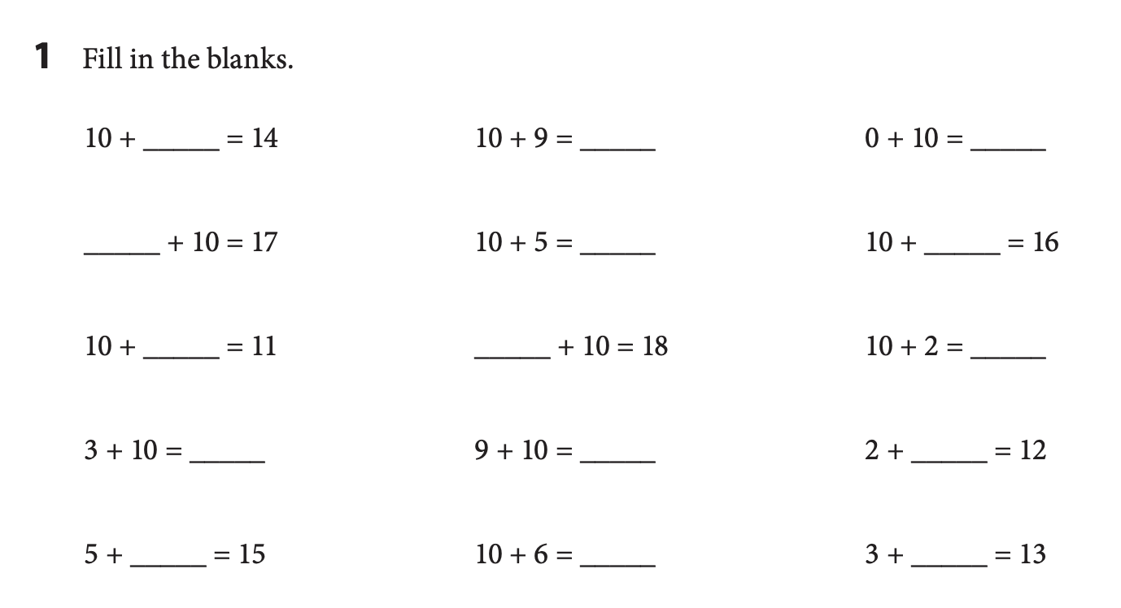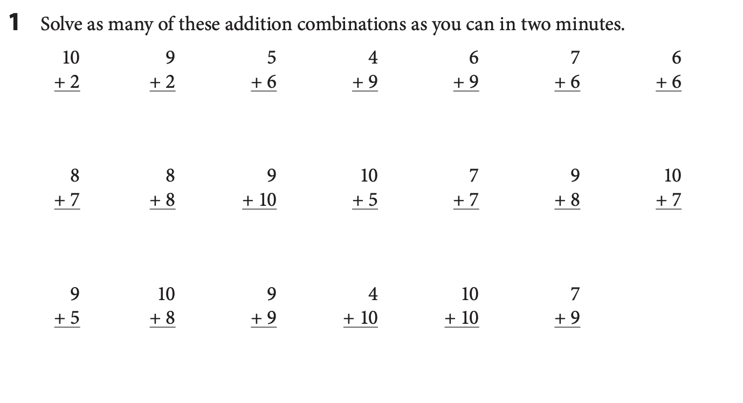

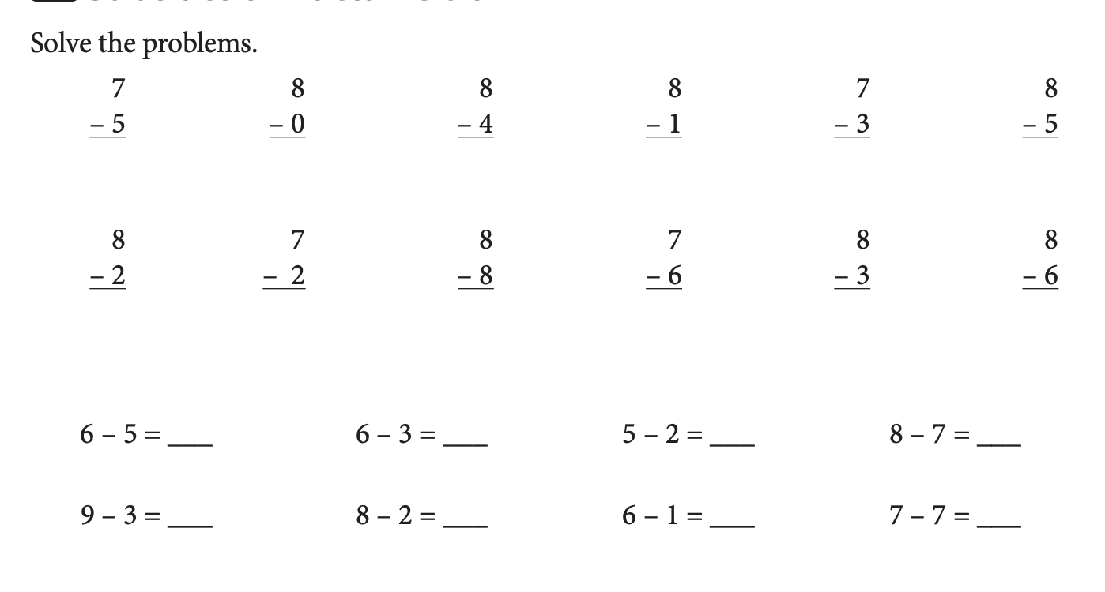

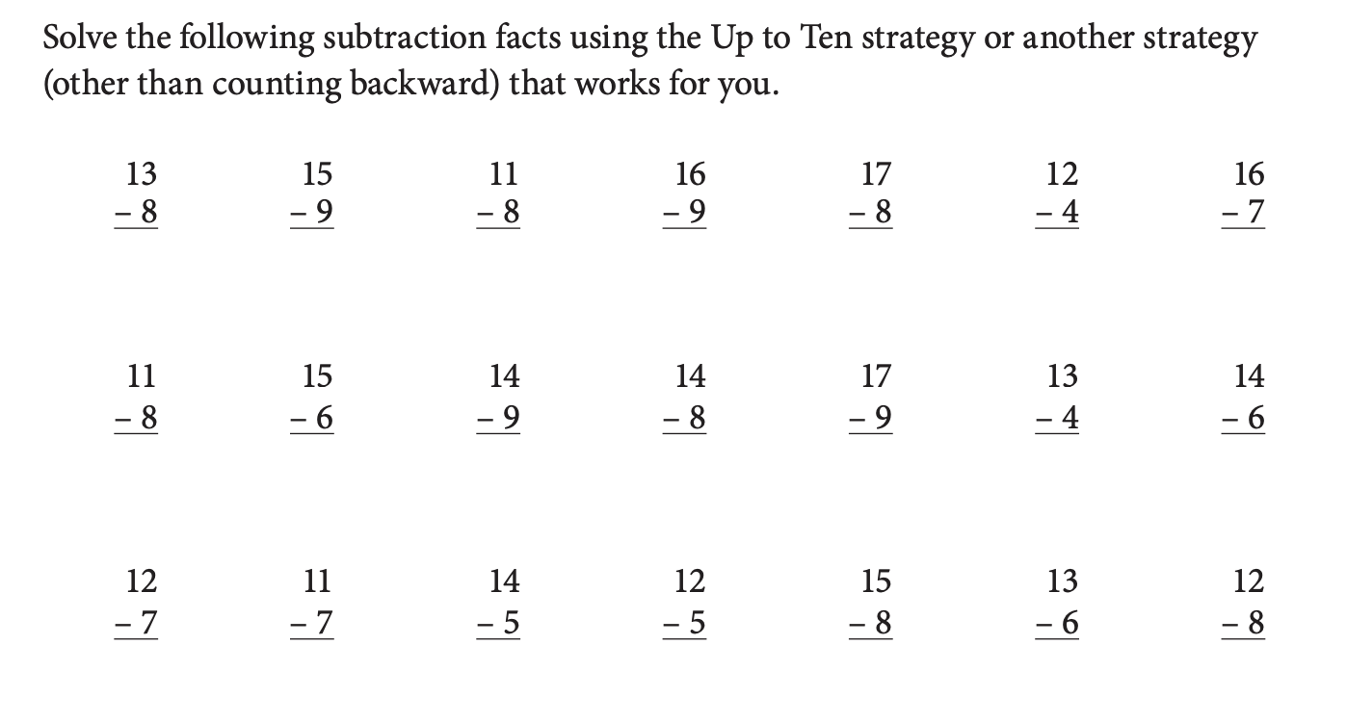

**Week 2**

**I can…** tell how many 100s, 10s, and 1s make a number.

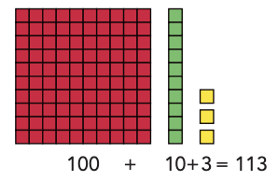

___________________________________________________

**For Families**

| **Understanding the math:** Place value means understanding numbers in our “base ten” system which means numbers are made up of groups of 10s. 7 tens is 70, 10 hundreds is 1,000, 10 hundred-thousands is a million! When students can name how many 100s, 10s and 1s in a number they develop a deeper understanding of our number system and can use those skills to add and subtract. Understanding place value also will help students understand decimals, multiplication and exponents, just to name a few things! | |
| --- | --- |
| **Resources:**  **-**Your child frequently worked with place value blocks this year (premade objects that show groups of 1s, 10s, and 100s.) You can use a digital version at: <https://apps.mathlearningcenter.org/number-pieces/>Try clicking the red, yellow, and green squares at the bottom left and then have your child build different numbers! | **Questions to Ask Your Child :**  -How many bundles of 10 are in 64? What if I added another bundle of ten? What if I took 2 bundles away?  -How many 100s are in 830?  -How many 10s make 100?  -Can you write a number sentence to show 273? (200 +70+3) |

Activity of the Week

Go on a big number hunt! Find two big numbers in your house or your neighborhood. Try to figure out how many 100s, 10s, and 1s are in that number. Draw or write what you found and how many 100s, 10s and 1s.

| Ex: I found a puzzle that had 750 pieces. There are 7 hundreds, 5 tens, and 0 ones in 750. |
| --- |

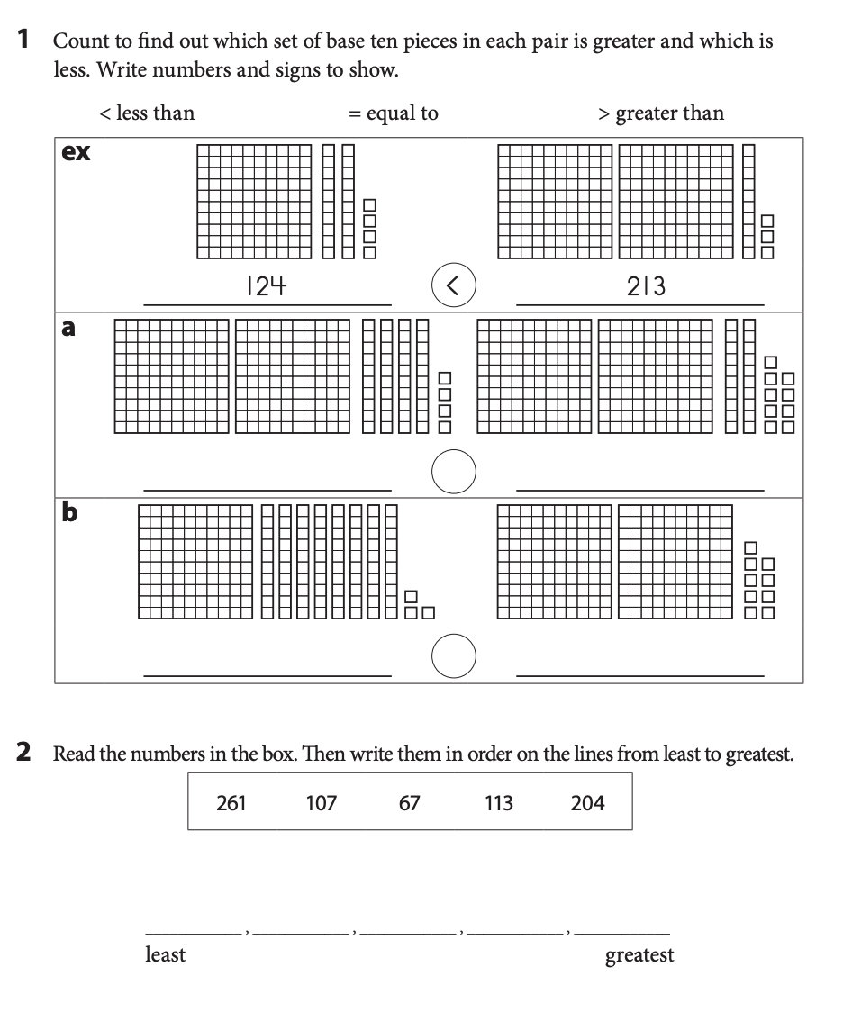

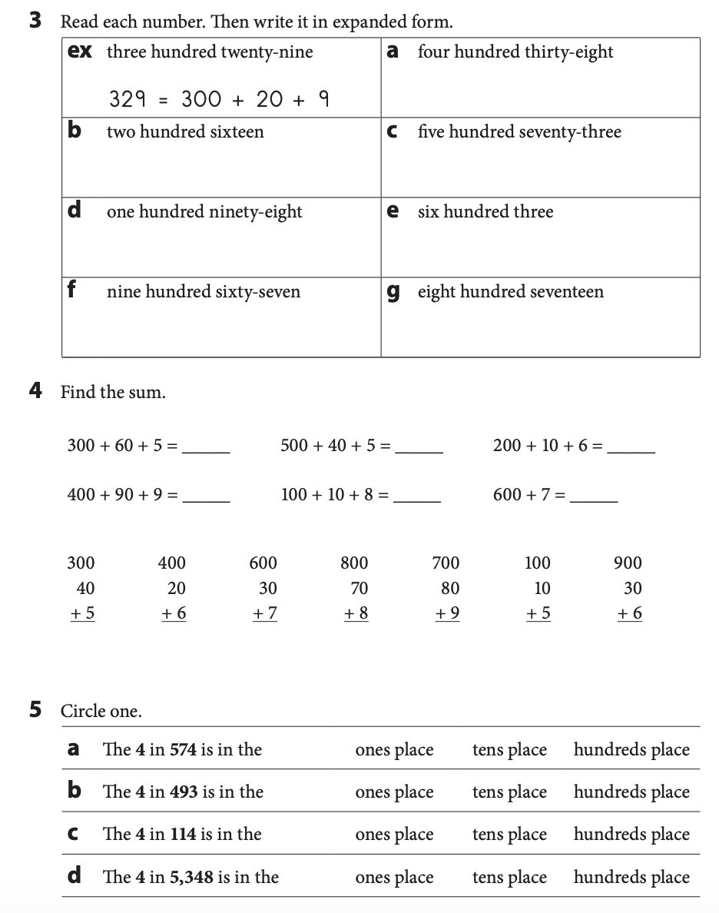 **Week 3**

**I can…** add using a number line

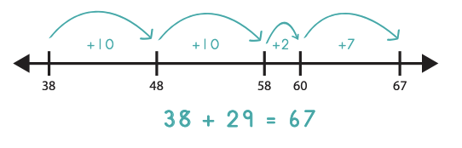

______________________________________________________________________

**For Families**

| **Understanding the math:** Students spent a large portion of second grade adding using a number line. They worked on starting at one number and making jumps of 100s, 10s, and 1s to add the other number. Encourage your child to make jumps of friendly numbers and to friendly numbers. So when adding 38+29 like the example above, They may start at 38 then add 20 by making two jumps of 10 to land on 58. Then they can make a jump of 2 to a friendly number-60. So far they have jumped 22, so they still need to jump 7 more. 60 plus a jump of 7 is easy- it is 67. They could have also taken 3 jumps of 10 to equal 30, landing on 68. Then they could jump back 1 to have only jumped 29. They still would have landed on the total, 67. | |
| --- | --- |
| **Resources:**  -Here is a digital number line for your child to use <https://apps.mathlearningcenter.org/number-line/>  -Try adding numbers yourself on the number line! You may find that you actually mentally often use strategies you would use if drawing jumps on a number line. | **Questions to Ask Your Child :**  **-**What will you jump first? Why?  -Can you jump to a friendly number?  -Is there another way you could jump on the number line?  -Where would you land if you added ten? 20? 30? |

Activity of the Week

Create a giant number line on the ground! You can use sidewalk chalk, a string, or just a straight line. Use big jumps to represent hops of 10 and small steps to represent hops of one. Solve 252+23 on your giant number line. Write what you did. Then try to have your family tell you other problems to solve!

| EX: If I solve 252+11, I would pretend that the beginning of my number line was 252. To first add 20 to 252, I would take two big jumps, landing on 262 and 272. Then, I would take three small steps to represent adding 3. I landed at 275. |
| --- |

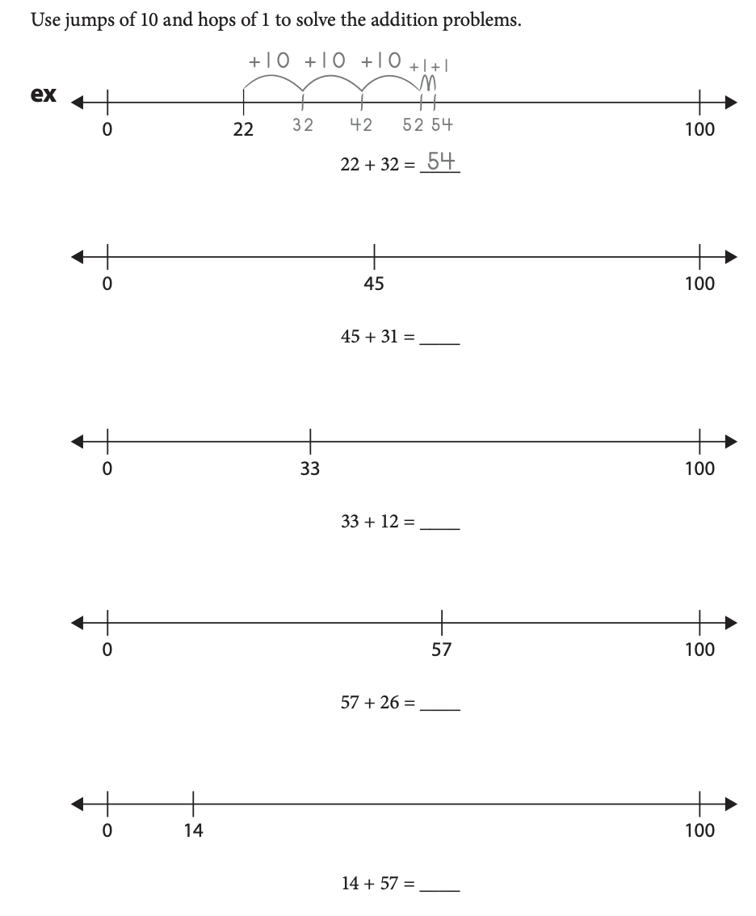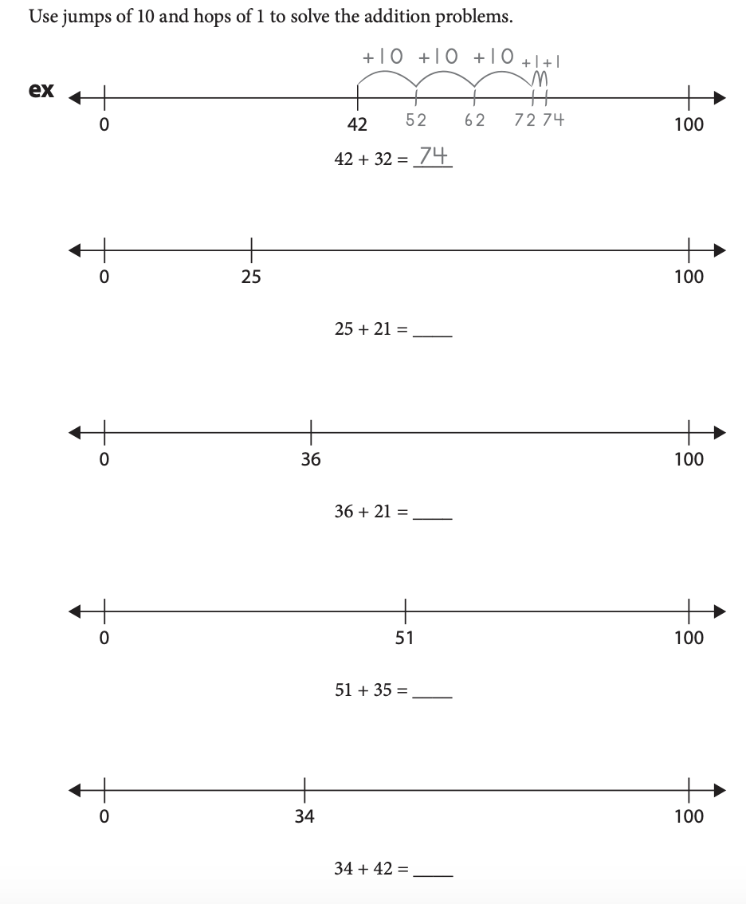

**Week 4**

**I can…** subtract using a number line.

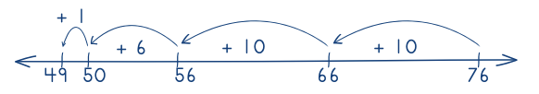 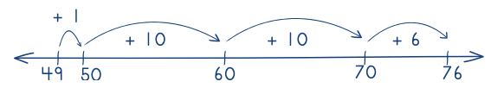

___________________________________________________

**For Families**

| **Understanding the math:** In second grade, students learned two ways to subtract on a number line (see above). Either by making jumps backwards or by putting their starting number and ending number and counting the jumps in between. Either strategy is acceptable. You may be thinking, why not just teach them the way I learned?? Often when we just teach the standard addition and subtraction methods, students don’t actually understand what they are doing. They may know they need to “borrow” but don’t know what this means. Just teaching the standard way often leads to mistakes and frustration and does not teach students number sense. Using a number line helps students visualize numbers and their relationships. It also helps them learn mental math strategies. Once they are very comfortable with the number line, we will teach them the standard methods! | |
| --- | --- |
| **Resources:**  -Here is a digital number line for your child to use <https://apps.mathlearningcenter.org/number-line/> | **Questions to Ask Your Child :**   * Can you try jumping backwards by 10s? * Where will you start? Why? * Can you count your jumps to find the difference? * Is there another way you could have jumped? |

Activity of the Week

Write a story problem that uses subtraction. Solve your story problem on a number line!

|  |
| --- |

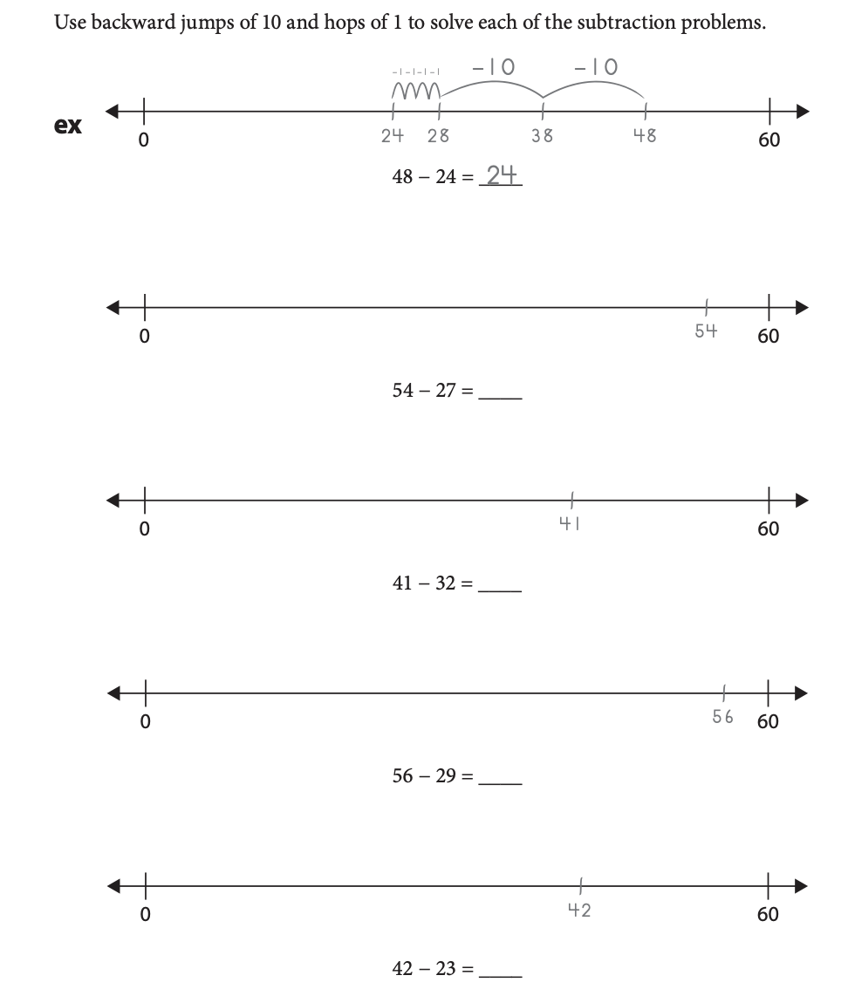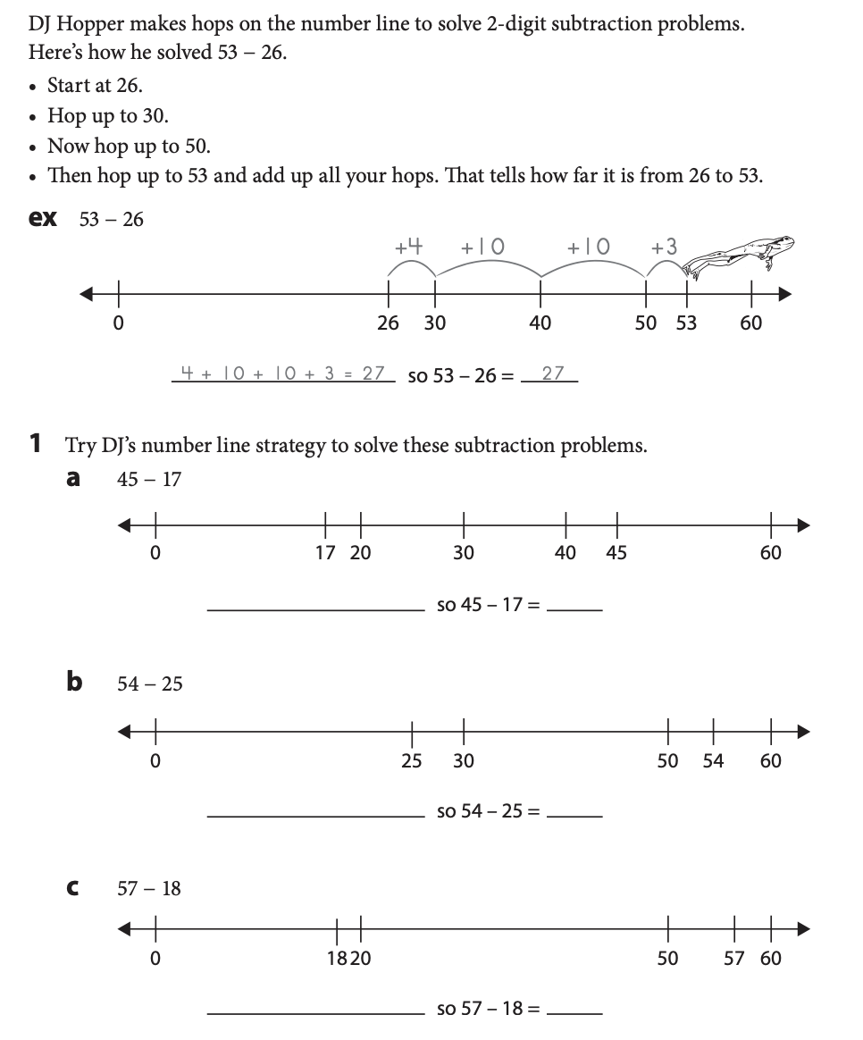

**Week 5**

**I can…** write andsolve addition and subtraction story problems.

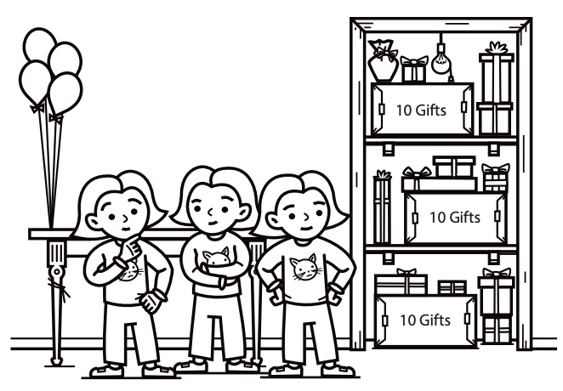

___________________________________________________

**For Families**

| **Understanding the math:** Word problems can be particularly challenging for any age student! One of the best ways you can help your child with word problems is by helping them visualize the problem. There are lots of ways to do this. You can physically act out the problem together. You can use a tool like a number rack or counters. You can also have them draw a picture of what is happening. Once they can clearly visualize the problem, they can then focus on the math to solve it! By third grade, they should always be writing an equation to match their problem and labeling their answer (so it shouldn’t just be 12, it should be 12 **books** or whatever the question is asking about.) | |
| --- | --- |
| **Resources:**  -Using the number line and place value blocks will again be very helpful with word problems. Students can build what is happening in the story problems. Here are the digital ones:  <https://apps.mathlearningcenter.org/number-line/>  <https://apps.mathlearningcenter.org/number-pieces/> | **Questions to Ask Your Child :**   * What do you know in this problem? * Can you act out what is happening? Can you draw it? * Can you write a number sentence to match this problem? * What operation do you need to do to solve this problem? |

Activity of the Week

Write an addition story problem that has to do with summer. Remember story problems have questions! Don’t forget to solve your problem.

|  |
| --- |

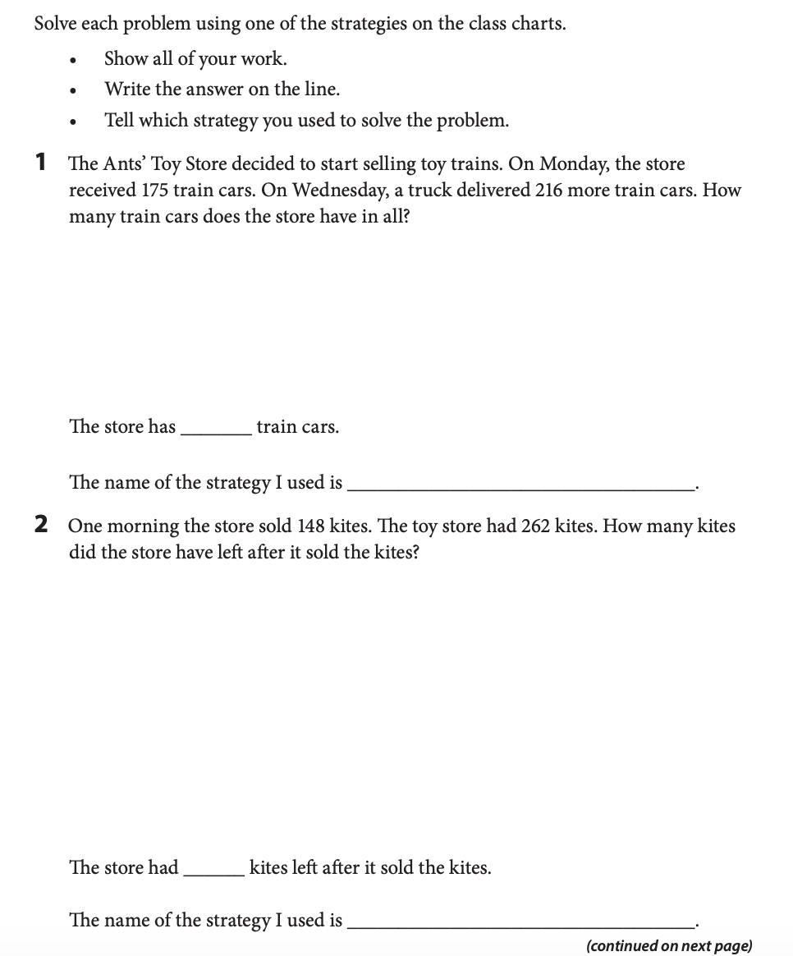

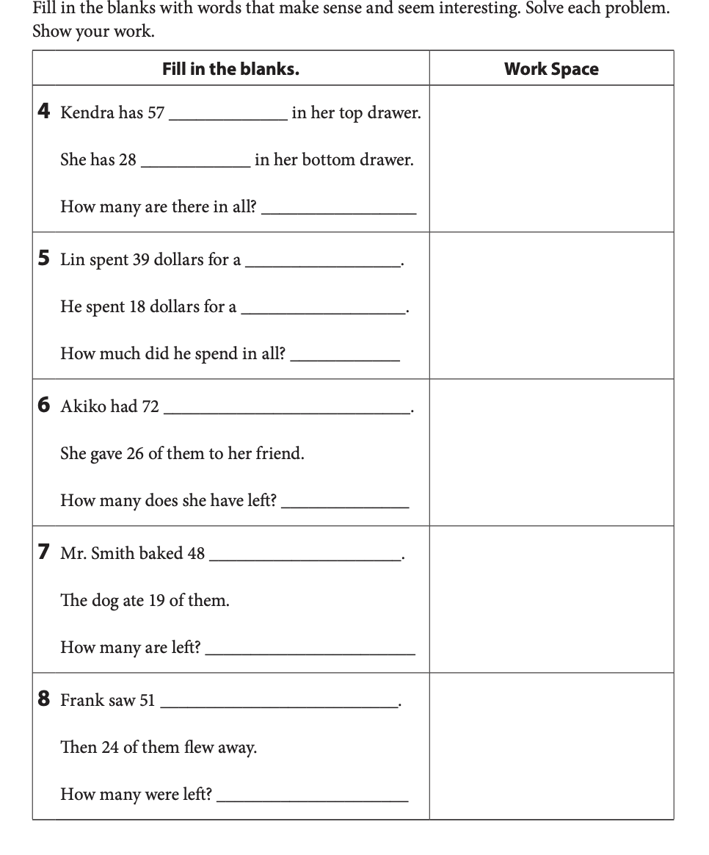

**Week 6**

**I can…** measure and estimate lengths, using an appropriate tool.

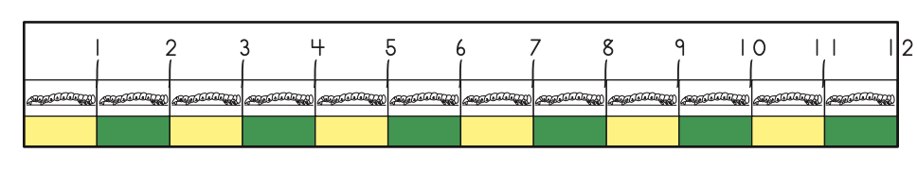

___________________________________________________

**For Families**

| **Understanding the math:** Second graders spent a lot of time this year working on measurement. They learned about inches, yards, and feet as well as centimeters and meters and the relationship between each. They worked on measuring things but also estimating measurements. In addition they thought about what tools would be best to use for measuring different objects (you might use an ruler to measure a book, but it would be better to use a yardstick to measure the length of a classroom.) In third grade, they will work on other forms of measurement (weight, capacity, etc). | |
| --- | --- |
| **Resources:**  -Talk about measurement! Any time you are measuring something, whether for length or another form of measurement (cups of flour for a recipe, the weight of your produce at the grocery store), include your child!  -Here is a virtual ruler: <https://www.piliapp.com/actual-size/inch-ruler/> | **Questions to Ask Your Child :**  -What tool would you use to measure ____?  -About how many yards is ____?  -How many inches is _____? How do you know?  -Be sure your child is lining up their ruler with the end of the object- its a common mistake for students to line up the “1” on the ruler with the beginning of the object. |

Activity of the Week

Throughout this week, look for ways your family uses measurement (the kitchen is one place measurement is often used!). Write or draw about one way you found.

|  |
| --- |

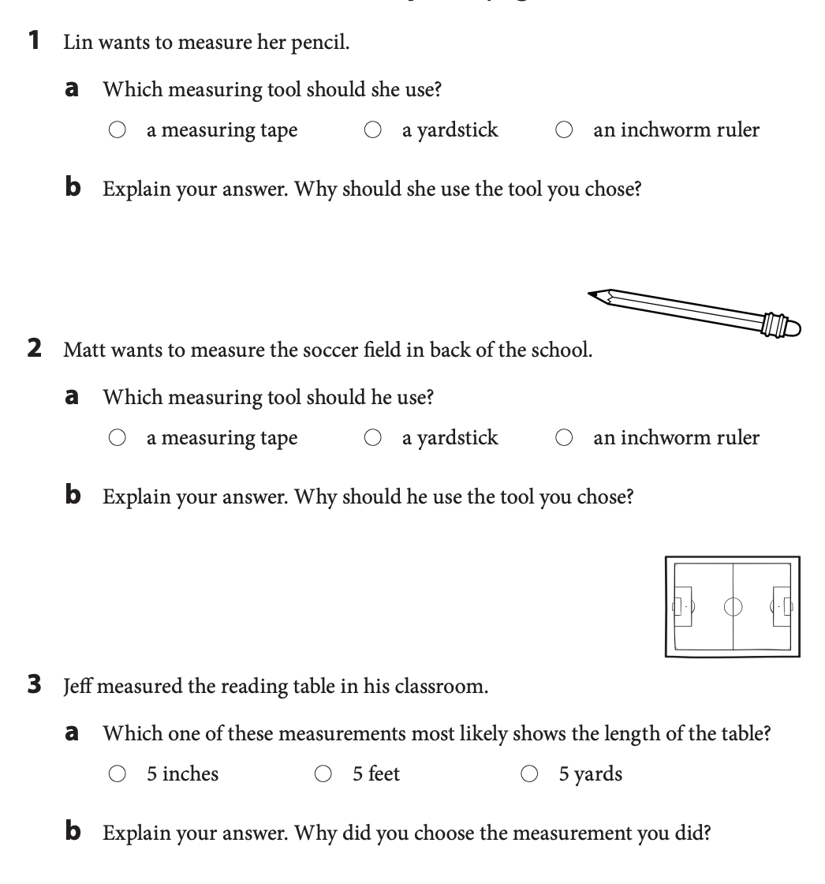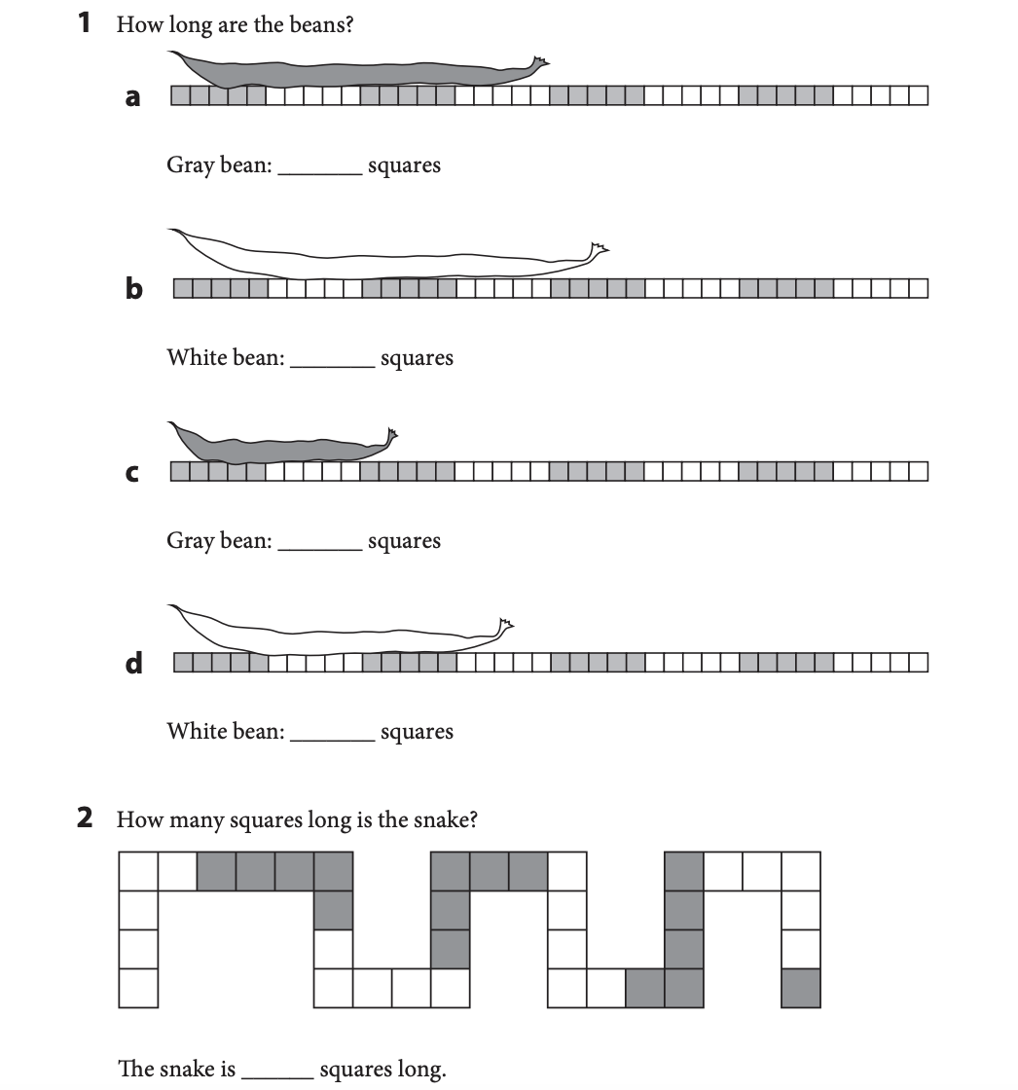

**Week 7**

**I can…** add and subtract lengths.

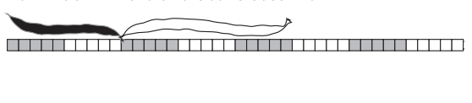

**For Families**

| **Understanding the math:** Students learned about length, addition, and subtraction this year. They combined all those skills to add and subtract lengths. There are many strategies students used to do this. They may add on a number line, make place value blocks, count by ones, or use the standard algorithm. All of these are acceptable strategies. Encourage your child to be flexible with the kinds of strategies they use- different problems are easier to complete using different strategies. If your child is always using one strategy, encourage them to try another! This will help develop flexible problem solving skills. | |
| --- | --- |
| **Resources:**  -Online ruler: <https://www.piliapp.com/actual-size/inch-ruler/>  -Online number line: <https://apps.mathlearningcenter.org/number-line/>  -Online place value blocks: <https://apps.mathlearningcenter.org/number-pieces/>  -All of the above tools are resources you should encourage your child to use to solve problems this week! | **Questions to Ask Your Child :**  -What strategy could you use to solve this problem? Is there another way you could do it?  -How did you know you needed to add for this problem?  -What will you do first (second, third..)? |

Activity of the Week

In the space below, design your dream bedroom. Label 5 objects with what they are and what you estimate their length to be in real life with the unit (inches, yards or feet). Remember what you know about measurement- a bed might not be 2 inches long, but could be two yards long and a big tv would not be 60 feet long, but could be 60 inches.

|  |
| --- |

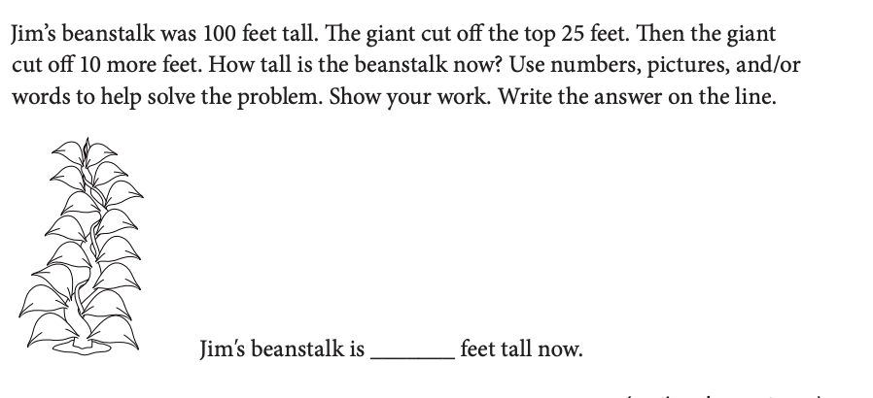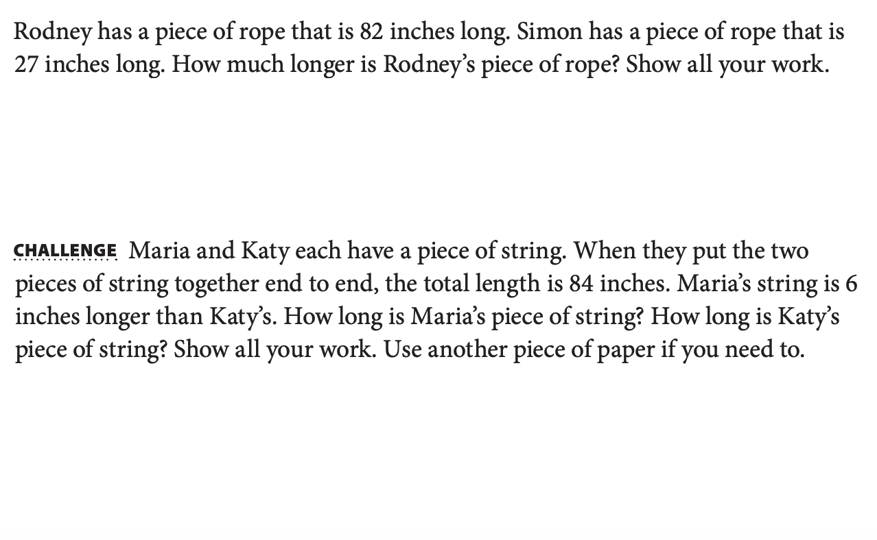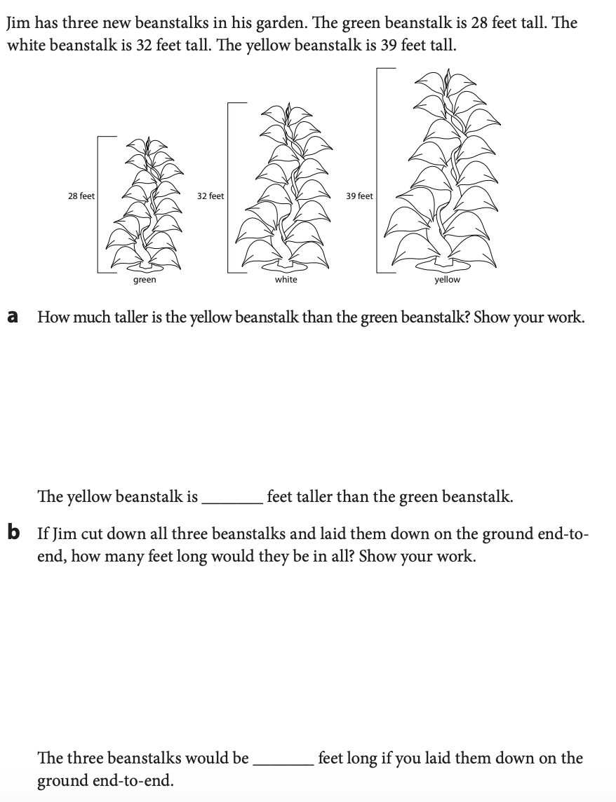

**Week 8**

**I can…** create and answer questions about graphs.

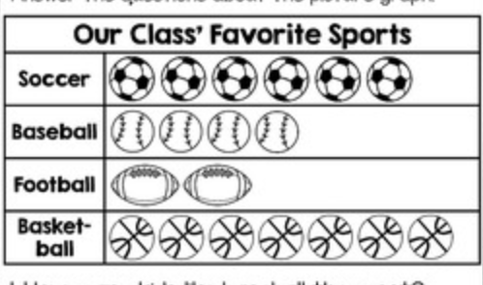

______________________________________________________

**For Families**

| **Understanding the math:** In second grade your child learned about a few types of graphs: Picture graphs, like the one above, tally charts (with tally marks), and bar graphs (graphs with bars above or to the side of each option). Graphs help us organize our thinking, make conclusions, and show information. It is important for your child to be able to create and interpret graphs not just for their future math learning, but also as a skill they will use throughout their life. They will use graphs in science class, they will see graphs in their history textbooks, and they will see graphs in news stories. Being able to understand graphs is a lifelong skill! | |
| --- | --- |
| **Resources:**  **-**Children love to ask questions and learn about their families. Help them to create graphs about what they learn. Here is a virtual graph making tool you can use: [https://toytheater.com/graph-color-bars](https://toytheater.com/graph-color-bars/)/ | **Questions to Ask Your Child :**  -Which has the most? How do you know?  -How many votes does ___ have?  -How many more ____ than ____ are there?  -What is the total number of votes? |

Activity of the Week

Create a question survey with four answer choices for your family (for example, do what is your favorite color- red, blue, pink, or orange?). Try to ask 10 people. It’s a great excuse to call family members! Make a graph of your survey below, coloring in the boxes for each answer. Then answer the questions.

| **Question: __________________________________________________________**  **___________________________________________________________________**   |  |  |  |  |  |  |  |  |  |  |  | | --- | --- | --- | --- | --- | --- | --- | --- | --- | --- | --- | |  |  |  |  |  |  |  |  |  |  |  | |  |  |  |  |  |  |  |  |  |  |  | |  |  |  |  |  |  |  |  |  |  |  | | **Options** | 1 | 2 | 3 | 4 | 5 | 6 | 7 | 8 | 9 | 10 |   What option had the most votes? _____________  What option had the least? ______  How many more people voted for the most option than the least? _________ |
| --- | --- | --- | --- | --- | --- | --- | --- | --- | --- | --- | --- | --- | --- | --- | --- | --- | --- | --- | --- | --- | --- | --- | --- | --- | --- | --- | --- | --- | --- | --- | --- | --- | --- | --- | --- | --- | --- | --- | --- | --- | --- | --- | --- | --- | --- | --- | --- | --- | --- | --- | --- | --- | --- | --- | --- |

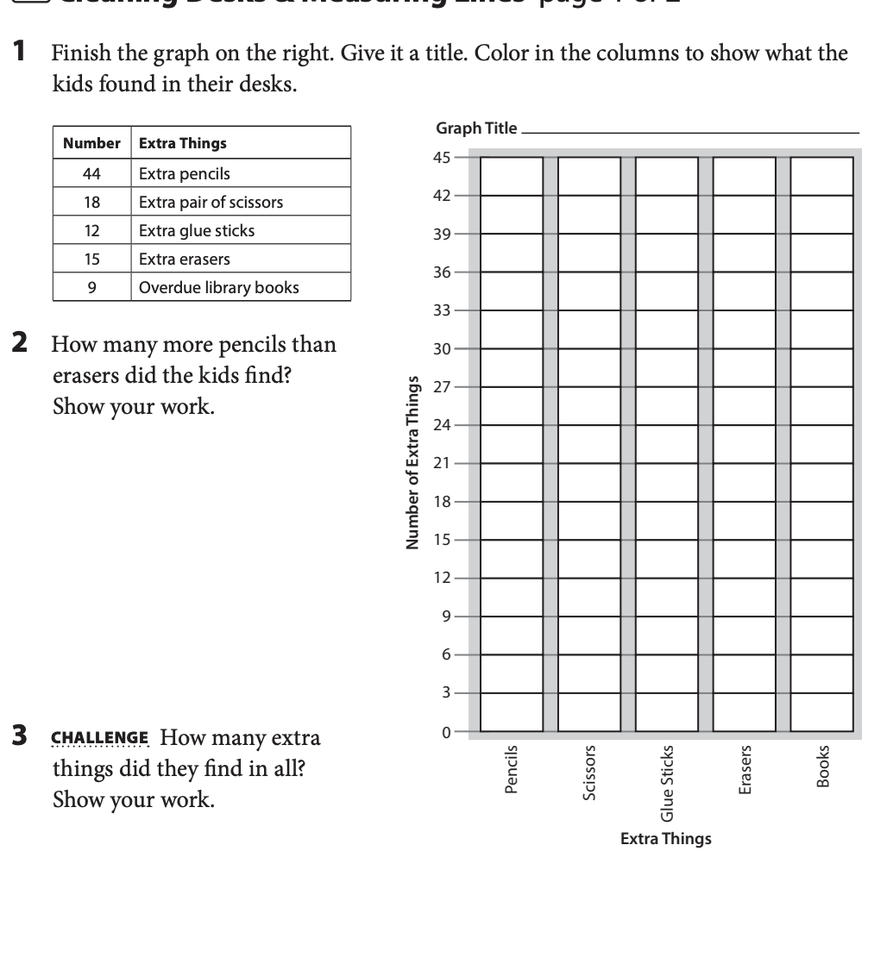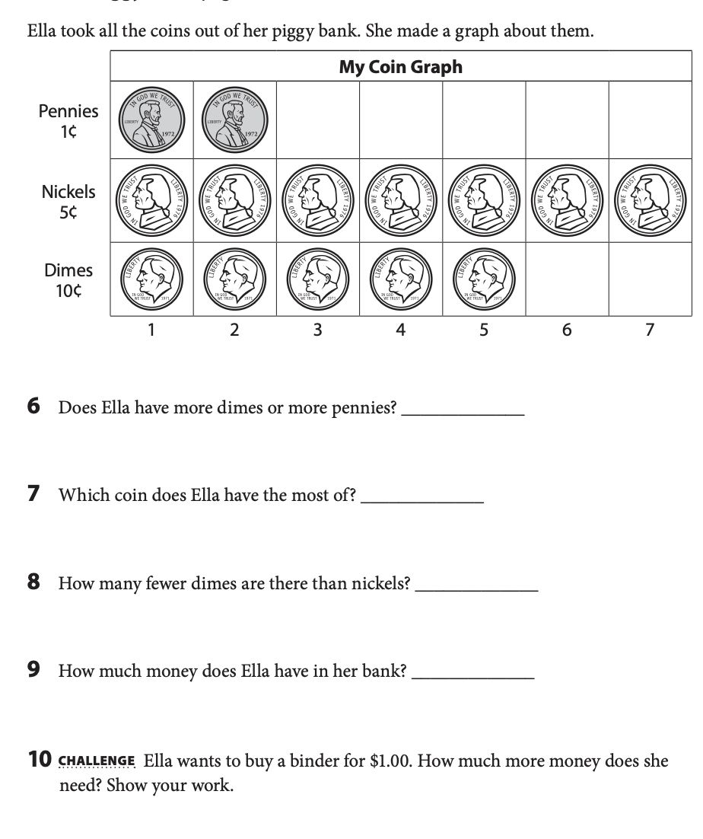

**Week 9**

**I can…** I can tell time to the nearest 5 minutes.

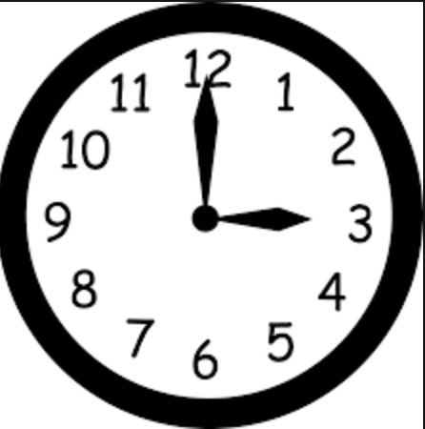

___________________________________________________

**For Families**

| **Understanding the math:** In second grade, your child learned how to tell time to the nearest 5 minutes (not yet to the minute). Telling time is another great math skill to just talk with your child about. Tell them the time things are happening, ask them what time it is. Even though most of us don’t have analog clocks, it’s still a valuable skill to be able to read one. Telling time on an analogue clock also helps children count by fives and understand fractions (half an hour). | |
| --- | --- |
| **Resources:**  -Here is a virtual analogue clock to use with your child. <https://toytheater.com/clock/> | **Questions to Ask Your Child :**  -What time is it?  -How did you know it was ____?  -Where does the hour hand point when its ___ o’clock?  -Where does the minute hand point when it’s 8:35?  -How many hours until ____? |

Activity of the Week

With the help of your family create a schedule for your day with the time and activity and write it below. Your schedule should have 5 things to do on it. Try to follow it! Check the clock frequently to see if you are on schedule!

|  |
| --- |

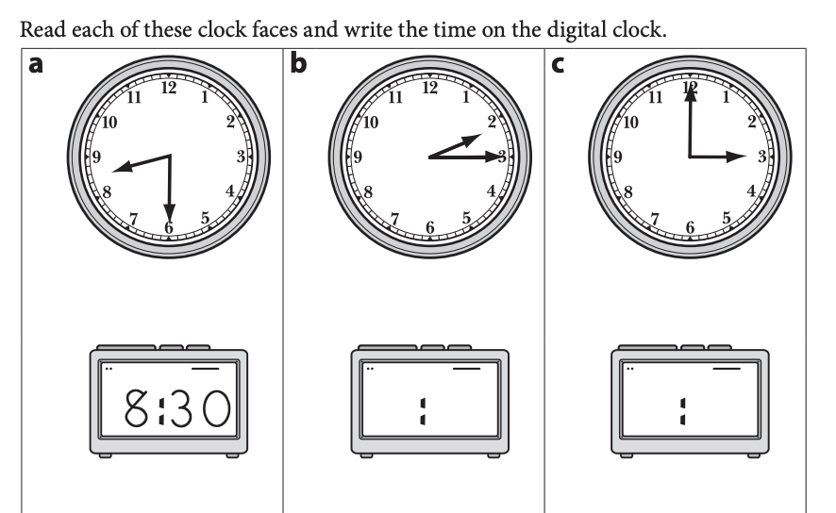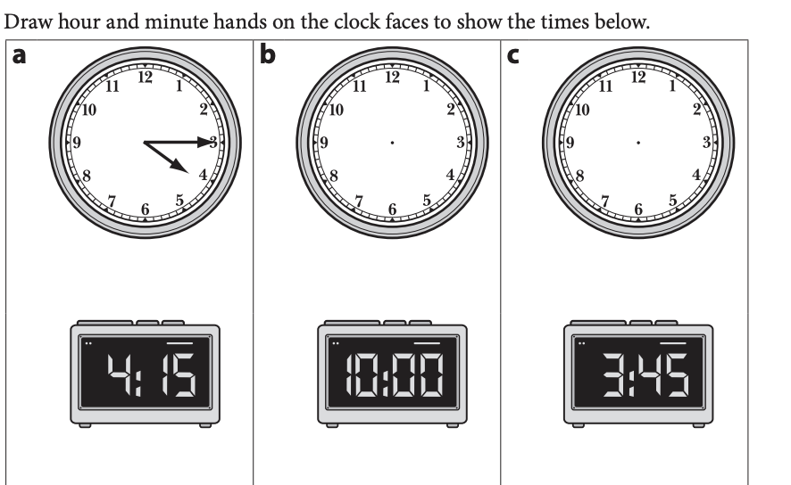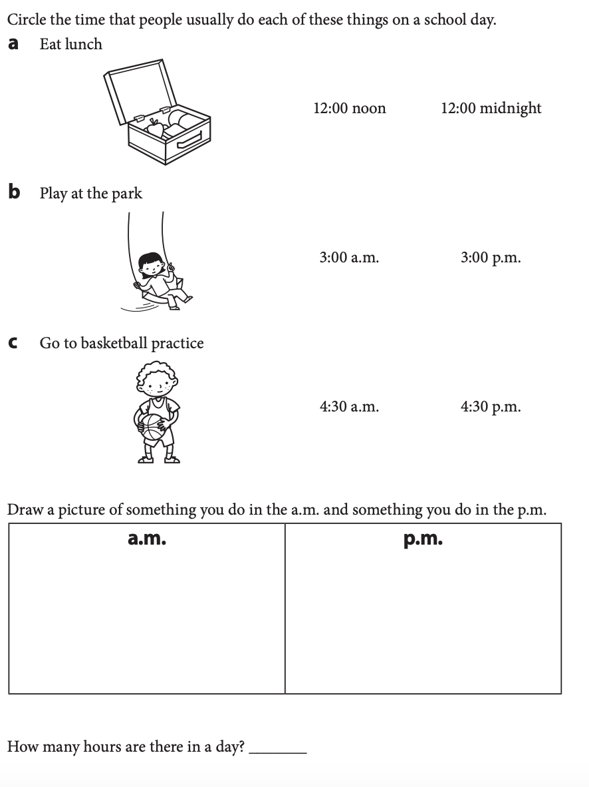

**Week 10**

**I can…** solve word problems using money.



___________________________________________________

**For Families**

| **Understanding the math:** Understanding money is not only a great life skill, but also helps students better understand place value and our number system. 10 pennies make a dime and 10 dimes make a dollar, just like 10 ones make 10 and 10 tens make 100. 42 cents can be made with 4 dimes and 2 pennies, just as the number 42 is made of 4 tens and 2 ones. Help your child make these connections this week! | |
| --- | --- |
| **Resources:**  -Online money pieces:  <https://apps.mathlearningcenter.org/money-pieces/>  -Talk to your child about money! Ask them to read amounts at the grocery store, to count the change you get, to figure out how much two items would cost together, to if they have enough money to pay for something! | **Questions to Ask Your Child :**  -How can you make $0.72? Can you use other coins?  -What coins could I use if I wanted to pay for these two items?  -What if I tried to pay with a ten dollar bill? Would I have enough? How much change would I get?  -How many pennies is the same as $1.76? How many dimes is the same as $2.80?  -Make sure your child is using the dollar or cents symbol and decimal point correctly! |

Activity of the Week

Prepare a shopping list! Choose 5 items you want to buy. Write their name and cost here (you can look up costs online). Then answer the questions

| | **Item** | **Cost** | | --- | --- | |  |  | |  |  | |  |  | |  |  | |  |  |   **What is the total amount of your shopping list?______________________**  **If you pay with a $100 bill, will you have enough money?_______________** |
| --- | --- | --- | --- | --- | --- | --- | --- | --- | --- | --- | --- | --- |

